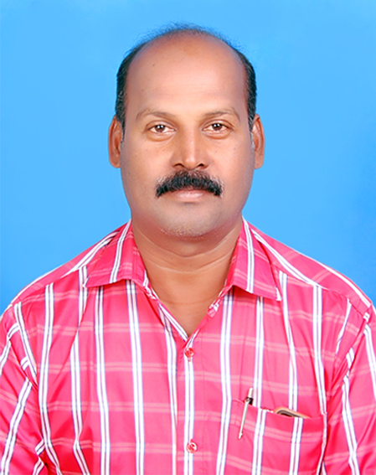
N. VENKATESAN
No;53B, M S Garden,
Nalleeswarar Nagar,
Thirumanam village,
Pattabiram, Chennai-600072
Tamilnadu,INDIA
Mobile: 8072656280
Email: venkat.n2010@gmail.com

Objective

To be an Good Management professional in the dynamic world of competition, where I can contribute my expertise for the company’s growth and individual development. I have been an asset to every company I have worked for.

Industry Exposure

  - AUTOMOTIVE ( SALES & MARKETING )

  - DEALER, DISTRIBUTION & DIRECT FLEET MANGEMENT.

  - PROMOTIONS ACTIVITY.FOR DEALERS & DISTRIBUTORS & FLEET.

  - RETAIL MARKETING. CUSTOMER SERVICE

CAREER HIGHLIGHTS

ELGI RUBBER COMPANY LTD March 2021 to till now
Branch Manager- Vellore
All tyres Truck&LCV Retreading

Handling branch sales and sales officers
overall branch profit control.

VERTIGO TYRES PRIVATE LIMITED April 2020 to march 2021
STATE MANAGER – TAMILNADU

Covering : TAMILNADU/PONDY
TWO WHEELER /3 WHEELER TYRE
- Distribution channel management.
- Handling entire Tamilnadu and Pondicherry
.Responsible for Sales, new market development

BALU IRON AND STEEL COMPANY
(Distributor south - JSW STEEL LTD

AREA SALES MANAGER 2017 Dec To 2020 April
Chennai Region

- Dealer channel management.
- Chennai Area covering for sales through dealer channel
- Handling key projects & Architect

CEAT LTD.
TERRITORY MANAGER ( SALES) 2010 MAY TO 2017 NOV

Covering : CHENNAI SOUTH ARCOT/NORTH ARCOT/PONDY
TRUCK/LCV/Farm/PCR/OTR/TW
- Distribution & Dealer channel management.
- Managing Chennai and Pondicherry depots covering 6 districts below
Chennai, Vellore, Pondy, Tiruvannamalai, Villupuram & kallakuruchi.
- Responsible for Sales, dealer Management & new market development.
- Inspection of service failed tyres and timely solution to end users
- CFA handling for stock requirement
- Dealer improvement plan with action.

BEST TERITORRY MANAGER (SALES) AWARD - 2012 ENTIRE TAMILNADU & PONDY
- Territory Manager – Customer Service
- All OEM – sales and claim inspection and resolution
- BEST TERRITORY MANAGER - CUSTOMER SERVICE AWARD 2014
- Direct Fleet Account Handling for sales
- Claim Resolution and training given for all OEM technicians

BIRLA TIRES 2008 MAY TO 2010 MARCH

SALES ENGINEER ( sales and service)

TRUCK/LCV/PCR/FARM/OTR/TW - DEALER MANAGEMENT
Covering entire NORTH ARCOT DIST.
Vellore/ Thiruvanamalai / Tirupathur/ Vaniyambadi
Sales Engineer - SOUTH SALES Champion Award 2010

Responsibilities:
- Team handling
- Demand generation of PCR/TRUCK/LCV/OTR/TW/FORM
- Educating the fleets on better Tyre Maintenance and usage of Tyre.
- Training the Fleet personal to Identify and timely remove of the Tyre for Repair/Retread.
- Recall CUSTOMER and purchase by regular interaction with the end users.
- Execution of events like Sales promotional meets, product launches
- appointing new Dealers.
- CFA handling for north arcot district.

APARAJITHA CORPORATE SERVICES PVT LTD 2007 MAR to 2008 APRIL
(Sub Unit of T.V.SUNDARAM IYENGAR & SONS LTD)
Commercial Vehicle
Business Development Manager
Covering; Entire Chennai
Responsibilities;
To find good Heavy commercial vehicle get sourcing from the customers

TVS. SUNDARAM INDUSTRIES LTD., 2005 APRIL TO 2007 FEBRAURY
Tyre solution Division

Asst manager sales
TRUCK/LCV/Farm/OTR – Commercial vehicle tyres Retreading
Covering; north and south, Entire Chennai

Responsibilities;

- To promote retreading through fleet customers and achieve target
- Campaign for awareness for brand and quality
- Developing the Business through Sales Agents and other Promotional activities

GENERAL TIRE RETREADING CORPORATION 2000 APRIL to 2005 MARCH

Sr.sales officer
TRUCK/LCV/ALL Commercial vehicle tyres Retreading
Covering: North and South Entire Chennai Zone.

Responsibilities;

- To promote retreading through fleet customers and achieve target.
- Campaign for customer awareness for brand and quality.

EDUCATIONAL QUALIFICATION:

B.B.A (Business Administration.) Madras University, Chennai.2007

TECHNICAL QUALIFICATION:

Diploma in Computer application(D.C.A.) & SAP, WORD, EXCEL

Typewriting: Higher

PERSONAL DETAILS

Date of Birth : 08.10.1970

Father’s Name : E. Natarajan

Martial status : Married

Languages Known : Tamil/English/(Hindi manageable)

Contact Mobile : 8072656280/9600997030

Current C.T.C : 6 lakhs

I hereby declare that all the information given by me are true to the best of my knowledge.

[N.VENKATESAN.]

