**Mehul Pandya**

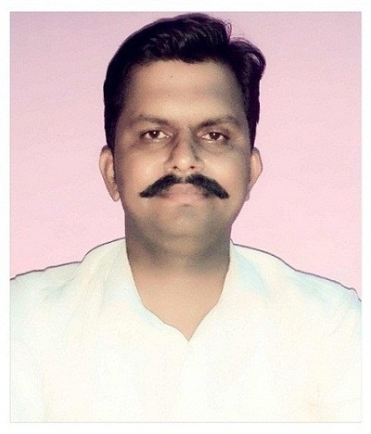

**Mobile:** 8239154005 **E-Mail:** [mpffld@gmail.com](mailto:mpffld@gmail.com)

## Willing to be a part of a highly professional organization with challenging and competitive environment, where I can use my knowledge as well as personal attributes to achieve the organizational goals.

## Professional Qualification

* **MBA Marketing & HR from DIVS VADODARA Gujarat. 2010**

## Academic Qualification

BA from Mohanlal Sukhadiya University Udaipur – 2004-2006

H.S.C. from – Rajasthan Board 2001

S.S.C. from – Rajasthan Board 2003

## Current Job and Position

# Company Name: RSWM Limited Fabric Division Mordi Banswara (Raj)

Officer at Finish Folding and Combo Division since Sept 2011.

To Handling all Fabric grading in Retail, RMG, FR And Combo Packaging.

## Computer skills

* Well brushed in MS-Office (Word, Excel, Power Point)
* Sound Knowledge of Internet
* Working over M3 and ERP

## Personal Attributes

## Abilities; Effective Communicational abilities

## Working focused on optimal use of resources,

## Extra Curricular Activity

*Playing Volleyball School and Organization level,*

*Anchoring and music. And Jyotish.*

## Personal Details

**Date of Birth** 19 Oct 1987

**Father’s Name** Sh. Mahendra Pandya

**Marital Status** Married

**Languages Known** English, Hindi & Gujarati

**Height**  6, 2”

**Address** Janamedi Banswara

BANSWARA-327001

**Mehul Pandya**

**Date -**