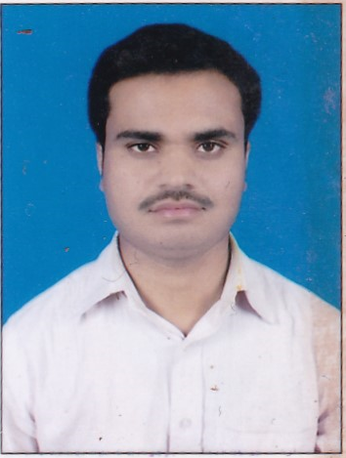

***CURRICULM VITAE***

**Chander Prakash**

H.No.- BXXX-2185A/74,

Village:-Gobindgarh, Post Offce.- Jugiana

Distt.- Ludhiana, Punjab.

Mob. No: +91-98555-66208

E-Mail : [chanderfutu@gmail.com](mailto:chanderfutu@gmail.com)

**OBJECTIVE:**

To achieve the job satisfaction while contributing all my best efforts in the growth of this organization.

**Experience**

* Currently working in **Mansarovar Forgings Pvt. Ltd**., Ludhiana From March,2021 to Till Dtd. as an **Sales Executive** .
* Worked in **Eastman Cast & Forge Ltd** , Ludhiana **From July,2011 to March,2021** as an **Sr. Assistant in Sales & Despatch**.
* Worked in **Emson Tools Mfg.Corpn. Ltd**., Focal Point, Ludhiana as a Computer Operator in Accounts & Documentation.

**Educational Details:**

* Matriculation (10th **) :** P.S.E.B. Mohali
* Intermediate (10+2) **:** N.I.O.S
* Diploma **:** DCA **(Punjab Technical University)**
* Graduation **:** Bs.c (IT) **(Punjab Technical University)**
* Post Graduation  **:** MBA **(Lovely Professional University)**

**Knowledge**

* **Knowledge of SAP software for Sales Modules for Sale Order generate for OEM, Export or Domestic.**
* **Knowledge of SAP software for Purchase Modules for Purchase Order generate or Purchase Bill Movement in Different Warehouse.**
* **Knowledge of Ramco software as a Champion User.**

**Computer Skills**

Operating Systems **:** Windows 7,8,Windows Xp,Windows 2010, MS-Office.

Computer Software  **:** SAP, Ramco & Skynet

**Responsibilities:**

* Responsible to maintain all the Record related to Dispatch.
* Proper documentation in sale related document.
* Proper Billing in SAP System (OEM, Domestic & Export)
* Sale Order Punching in SAP as per Monthly Schedule (OEM, Domestic & Export).
* To make Purchase Order in SAP.
* Export Packing List Make in SAP According to Export Documentation.
* Transporter Details (GR) Entry in SAP For OEM Customer.
* Packing Material Issue Through SAP According to Monthly Dispatch with in 1st week of every month..

**Personality Traits:**

Target oriented, positive attitude, good knowledge about Computers, ambitious punctuality, excellent

**What I am looking forward to in an Organization.**

Good working environment, stability, chance to grow in my career as well as stature and an overall improvement in my personality.

**Personal Profile:**

**Name**  **: Chander Prakash**

**Father's name** **:** Sh. Upendra Narayan.

**Date of birth** **:** July 15, 1988

**Marital status** **:** Married

**Languages Known** **:** Hindi, Punjabi and English.

**Nationality** **:** Indian

**Strength :** I believe in my Hard work & my Patience.

I shall be grateful to you, if a chance given to me to serve your esteemed organization under your kind control. I assure you that I shall spare no pains in the discharge of my duties honestly and faithfully.

**(Chander Prakash)**