**C A R E E R M I L E S T O N E S**

* Organized **Corporate Presentation to then ’CM of Gujarat Shri Narendra Modiji** and delivered presentation for sanction of private port

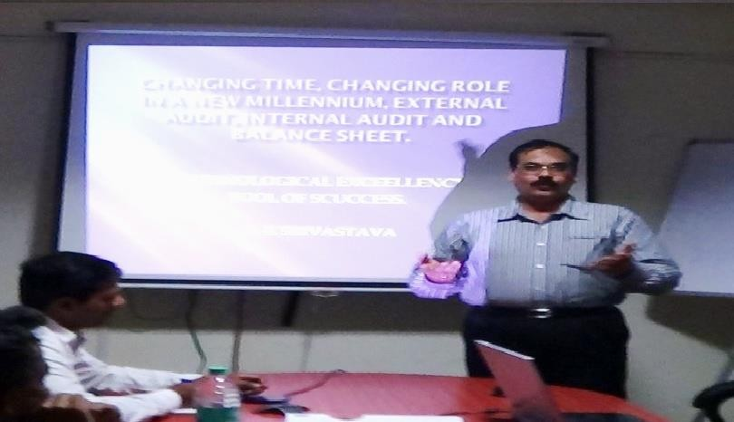

Strategic and hands-on decision-maker deeply experienced in **Commercial, Business Development**, **accounting** and **financial management** with proven record of establishing Cross functional partnership to deliver stellar results for more than **37 years**. Agile, Global strategic leader driving operation management within **Finance, Commercial, Audit, Projects, HR & Admin, Market, Analytics and business development areas** in premier **Fortune 500 companies**. Expert generalist in overseeing all aspects of a multi-million dollar business exceeding profit and sales goal. Demonstrated ability to streamline business operations that drive growth and increase efficiency and bottom-line profit.

Pune| Mumbai /Vadodara +91-9923833970 [Tony_19622000@yahoo.com](mailto:Tony_19622000@yahoo.com)

**BUSINESS DEV. & GENERAL ADM.**

**Commercial Head || HR & ADMIN**

**CFO/FC II HEAD – BUSINESS II**

**ANIL KUMAR SRIVASTAVA**

**FINANCIAL CONNOISSEUR |**

* **SAP IMPLEMENTATION** at KLT Automotive, Bajaj and SPRL and Jyoti Structure Ltd making exisiting system modern and extremely efficient.

# E X P E R T I S E

## Commercial/ Audit/ Finance Cost Control & Reduction

## HR & Admin

**TPM & SAP**

**Project management Supply chain management Business Development,**

**Sales accounting for multi channel COO/Unit Head responsibilities**

**Budgeting and profit management Tendering & Joint ventures.**

**Stores accounting/Training.**

**S K I L L S**

**SAP ; implementation** –KLT, JSL, SPRL, Bajaj.

**Tally** : Knowledge of working in Tally.

**M S Office** : Word, Excel, Power point .

#### In depth expertise of TPM Training with Mr. K Z Mizota #3rdRanked Senior Consultant at Japan Institute of Plant Maintenance

* Led corporate team in **driving cost-reduction initiatives**

that resulted in **$5.7 million**

* Improve support **service level by 32%** at Bajaj Hindustan Limited and accuracy of budget forecasts across all organizations
* Exposure of Working overseas leading **multi-millionaire business** at Sundry locations of **Central Asia (Kazakhstan) South Asia, Eastern Europe and Africa**
* **Planned and Executed Multi-billion project**s including Jetty/Marine Constructions (4bn) / Road Projects (5.3bn) etc
* Sole **Authorized signatory** for operation of bank account in Bajaj, Uptron and SPRL.
* Led **Funding of 240mn** for HG School and HG Hotel business improvement with vehicle workshop.
* Indirect involvement in Improvising **customer service satisfaction 3%** annually through supply chain management initiatives, inventory control and flexible manufacturing practices.

**SUNDRY WORKING LOCATIONS**

**OVER SEAS** Kiev-Ukrain, Almaty- Kazak, Nepal, Bhutan, Nigeria,

**INDIA** Delhi, Rajasthan, Gujarat, MP, West Bengal, Andhar Pradesh

KLT Automotive & Tubular Ltd

Jyoti Structures Ltd, Bajaj

**Oracle ERP Package** in Shriram Pistons

**SAP IMPLEMENTATION.**

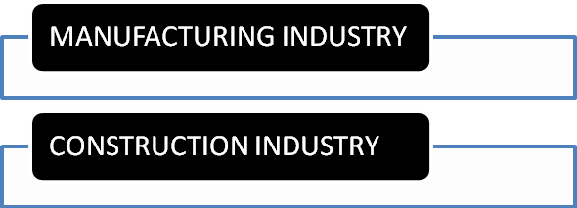

10 YEARS

Toll Automation, Water Distri.

Real Estate Low Cost Housing

Highways (BOT), Pipeline

Bridges, Private Ports, Jetty

2 YEARS

Sugar, Distillery, Education, Hotel

2 YEARS

Steel, Timber , Mineral,Cogen

2 YEARS

Transmission, Sub Station, R.E

15 YEARS

Electronics, Auto Components

EXPIRIENCE AT GLANCE

10 YEARS

27 YEARS

EXPIRIENCE SUMMARY *Rich experience of 32+ years*

|  |  |  |  |  |  |  |
| --- | --- | --- | --- | --- | --- | --- |
| **Description** | | | **DESIGNATION** | **CTC** | **TENURE** | **RESPONSIBILITIES** |
| **Gujarat Containers Ltd – 175 crore group) Barrel Manufacturer** | | | | | | |
| Gujarat Containers Ltd | | | **Vice President-** | 12,00,000.00+ |  | All Finance, Accounts, Commercial, Project Management , Budgeting, Business Development, Project Profitability, HR, Admin and liaison, Ensuring group business with growth and profitability. |
| Listed 175 crore company | | | **Commercial, HR** | Accommodation |  |
|  | | | **& Business Dev,** | +Mobile and | Current Job |
|  | | | **Finance & Accts** | other general |  |
|  | | | (group business) | facilities = CTC |  |
|  | | | Reporting to | 15 ,00,000.00 |  |
|  | | | Chairman. | p.a |  |
| **Reporting To Chairman** | |  | | **Location Gujarat- Vadodara** | |  |
| **M/S Alves Group (100 cr group ) Pharmaceutical & pharma equipment Manufacturing Company** | | | | | | |
| A group of company | **Director – Operations** | | | (Construction |  |  |
| Having 5 manufacturing | ( HR, Admin, Finance | | | Division) |  | All accounts, finance, commercial, audit |
| Plants – 4 in Mumbai & | & Accounts ) | | | 12,00,000.00+ |  | of 140 sites across country and ensuring |
| One in Solan, HP. | Reporting - Chairman | | | Accommodation |  | project profitability and budget |
| -Contract Manufacturing |  | | | +Mobile and |  | monitoring including variance report to |
| Pharma Equipment’s, |  | | | other general |  | management and site project |
| Own 400 medicine |  | | | facilities = CTC | 2 years | management. SAP |
|  |  | | | 13 ,00,000.00 p.a. |  |  |
|  |  | | |  |  |  |
|  |  | | |  |  |  |
|  |  | | |  |  |  |
|  |  | | |  |  |  |

|  |  |  |  |  |  |
| --- | --- | --- | --- | --- | --- |
| **Reporting To Chairman** | | | **Location – Mumbai - Maharashtra** | |  |
| **M/S H G Group of companies (1400 cr group ) – Infrastructure company** | | | | | |
| 1400 crore turnover | Financial Controller and Head – Internal Audit ( HG Group ) – **ADDITIONAL**  **Business Development, joint ventures, project management, tendering.** | | 10,35,000.00+ |  | All accounts, finance, commercial, 12 |
| with 1500 crore project | Accommodation |  | sites monitoring, budgeting, tendering, |
| M/S H G Realty pvt Ltd | +Mobile and |  | JV arrangement, Fund raising, Business |
| M/S H G International | other general |  | Development, Banking compliances, |
| Sch.  M/S H G Luxury Hotels M/S HG Central Workshop. | facilities = CTC  12,00,000.00 p.a. | 3 years | Taxation matters, debtors, creditors  etc. and other group business of school, hotel, realty. TALLY./BUSY. |
| M/S H G Poles and Tiles |  |  |  |
| **Paresh Group of Companies – Infrastructure and manufacturing group** | | | | | |
| 470 crore group of | | General Manager | 9,00,000.00 + |  | Group business which includes, |
| company having two | | – Commercial | furnished |  | Finance, Accounts, Commercial, |
| manufacturing plant and  7 construction companies | | (HOD) Business  Development, | accommodation  in Chembur + | 2 years | Business Development, project  management etc. |
| in Mumbai | |  | Company car= |  |  |
|  | |  | 1200000.00 |  |  |
| **Reporting To Chairman** | | | **Location : Mumbai** | | |
| **M/S Bajaj Hindusthan Limtied (Kinauni Plant ) Sugar , Distillery and Power Generation.** | | | | | |
| 2000 crore turnover, | | Manager – | CTC 8,68,000.00 |  | Final Accounts, Audit, Cane Accounting, |
| Sugar, Distillery, Cogen | | Finance & | ( Salary 6.5+ | 2 years ( Nov | funds raising, segment wise reporting |
| etc. | | Accounts ( HOD | furnished | 2007 to June | and variance, liaison with govt, banks, |
|  | | – Kinauni Plant | accommodation | 2009 ) | excise, Sales Accts. SAP |
|  | | – F&A Dept) | + transport ) |  |  |
| **Reporting To VP-F&A.** | | | **Location : Meerut** | | |
| **M/S Global Steel Holdings Limited, United Kingdom – Steel Manufacturer** | | | | | |
| Posted at Nigeria, - Steel | | Manager – | CTC 54000 USD | 1 year ( June | All accounting work such as bill |
| Plant in Delta and | | Finance |  | 2006 to Oct | processing, SOP preparation, budget |
| Ajakoata with Irone Ore | | &Accounts |  | 2007). Nigeria | monitoring, variance analysis etc. |
| Mine. | |  |  | operation Cl. |  |
| **Reporting To AVP- F&A** | | | **Location : Mumbai/ Delta, Nigeria.** | | |
| **M/S KLT Automotive & Tubular Products Limited – Automotive component manufacturer** | | | | | |
| 500 crore – Auto Comp | | Sr. Manager – | CTC 5,04,000.00 | 3 years ( june 2004 to June  2006 ). Overseas appointment | HOD-F&A-Pune Plant. , Final accounts |
| i.e. Chassis Frame for | | Fin.& Accts |  | of plant, SAP implementation, Excsie, |
| OEM, Steel plants-14 | | (HOD – F&A – |  | Sales Tax, Service Tax, Liaison with |
| plants in India and | | Pune Plant ) |  | TML, Stores, finance, Routine |
| Africa. | |  |  | accounting etc. |
| **Reporting To VP – F&A** | | | **Location Pune Plant** | | |
| **M/S Shriram Pistons & Rings Limited- - Automotive component manufacturer** | | | | | |
| 680 Crore- Auto | | Assistant | CTC 3,75,000,00 | 8 years ( Sept | Final Accounts , Sales Accounting, S. |
| Components, Like | | Manager – |  | 1993 to June | Tax, Service Tax, Salary, Vendor |
| Pistons, Pins, Rings, | | Finance & |  | 2004). | payment and bills processing, TPM |
| Engine Value, Gear Box | | Accounts |  | Reason to leave - | pillar, SAP Billing, CFT Resp. etc. |
| etc. for OEM. | |  |  | Better |  |
|  | |  |  | opportunity |  |
| **Reporting To Senior Manager – F&A.** | | | **Location : New Delhi & Pune** | | |
| **Uptron India Limited – TV, Computer, Capactior, Electronic product manufacturer.** | | | | | |
| ( U P Govt.-400 crore)- | | Jr. Accounts | CTC 1,20,000.00 | 10 years ( june 1983 to Sept  1993). Reason to leave Company closed | Final Accounts, Sales Accounting, |
| Electronic Goods like TV, | | Officer (HOD – |  | Govt. Liaison, dealing with banks and |
| Audio, Video, Control | | Accounts) in RO, |  | financial institutions, Audit, Sales Tax, |
| Instruments, Wireless | | Pune and EED, a |  | Excsie etc. |
| Sets, Capacitors etc. | | 15 crore |  |  |
|  | | turnover unit |  |  |

PROJECTS

Construction Projects

**Reporting To FC, HO. Location : Lucknow/ pune**

Completion of construction of Berth 13 at Kandla Port Trust, value 110 crore

2200 crore Dhankuni to Kharagpur project -129 kms road in West Bengal.

Business development of 400 crore projects i.e.KPT Berth project, Berth 16 project at KPT, Tendering and JV for Bunder Basin , Kandla and Bharti Dock, Chennai.

Pile Foundation business from IOCL, Mathura, BPCL, Uran.

New business of Geetapuram Port, Coke Oven Plant in Dolvi

,Mumbai, Angual, Udisha and Patratu, Ranchi, Jetty Extension work at Dolvi, Geetapuram Port., JSPL

Bridge Construction work at Kota, Rajasthan *Piling work for met work, bridge work and other general work along with various* miscellaneous construction wor

ROAD PROJECTS

Dhankuni Kharagpur Project – 2200 crore in West Bengal-

129 km.

Construction of Agra Inner Circle Road, Uttar Pradesh –

240 crore- 15 km.

Ajmer Kishangarh road project – 120 crore.

Construction of Bhim Devgarh Road, Rajasthan – 52 km.-

330 crore

Faizabad – Allahabad – Road Widening – 170 crore(UC-Just

Started).

Construction of Steel plant at JSPL, Angual, Odissa and JS,

Ranchi – 28 crore

Under Construction work of Sitarganj- Tanakpur Road,

Uttrakhand – 500 crore. (UC).

Jetty extension work at ESSAR, Hazira, Surat – 22 crore.

BUILDING CONSTRUCTIONS

Real Estate / New township Work at Uaipur, Rajasthan.

7 floor Building at Mumbai Near Kings Circule for ICI.

Construction of Ashoka Agam, Township, Pune.

•

8 Floor Building in Vashi, Ghansoli, Navi Mumbai.

ADVISORY SERVICES - CONSULTANT

Coke Oven plant at Dolvi, Jinal, Mumbai. 4 Floor building at Chembur, Mumbai.

**ASAHI INFRASTRUCUTRE LTD** Worked as General Manager ( Projects & Business Developments) and completed Affordable Housing Project at Jhunjhunu and got new projects in Rajasthan besides sublet Affordable Housing Project at Bikaner and Dausa. Close liaision with UDH department of Secretariat upto Secretary level and with local municipal corporation authorities

#### VISHWAKARMA SCALES / TOLLMAN INTERNATIONAL ( INDO BRITISH JV)- TOLL AUTOMATION PROEJCT IN NORTH AND SOUTH

General Manager –FCH ( Finance , Commercial & HR ) and PROJECT DIRECTOR for toll automation project in North and South India – 273 toll projects for full automation under IHMCL.

#### MGA INTERNATIONAL, SINGAPORE

Private Jetty, Free Trade Zone and International Timber Trade

#### GIRIJA INFRASTRUCTURE P LTD Infrastructure and Real Estate Projects

* **Monitoring, Control and Variance of Plant profit,** expense and other activities and submission of MIS reports upto BOD level.

CORE COMPETENCIES/SPOC/OTHER ACHIEVEMENTS

* **Project Management-Site Cost and Material consumption control** and to ensure that projected profits are intact.
* **Analysis and circulation** of variance reports.
* **Finance Management** - WC, Term Loan or Project Finance for Business Expansion.
* **Excellent relationship with banks** and **financial institutions**, private equity, market financier.
* **Final Accounts** with all routine accounting with in-depth checking of data and records
* All taxation matters - **Vat, Sales Tax, Excise, Service Tax etc.**

### All **liaison matters** - Financial Institutions, Govt. agencies and local authorities.

* **SAP, TPM** and Cost Reduction Management.
* **Compliance of all laws** such as Labour laws, PF, PT etc.
* **All HR and Admin Activity** including **HSE and safety implementation** and **compliance.**

### Audit work pertaining to factory, corporate including all departments for most efficient working.

* **Training to staff** for better working atmosphere and clear direction to work and results.

## Tendering, business development, joint ventures

### Cost Reduction and improvement projects – identification and execution.

* Sanction of licenses for factory.
* Consortium partners for big tenders as O&M, Technical, Finance partners.
* **Arrangement of funds** from Dubai and Singapore/NRI investments.
* **Construction project monitoring** i.e. Financial and Technical both with 100% assurance of Zero wastage unknown losses in project.

**KRA and Kaizen Projects** across all departments in any company.

## 100% CUSTOMER DELIGHT to all Internal and External Customers.

* **Thorough Internal Audit for Zero failure or losses in all area.**
* **Project Insurance** with highest discount **upto 94% in CAR/IAR/EAR etc policies.**

## Training to staff for cost effective working, zero defect working, motivation etc

* **Budget preparation and control**

OTHER PERSONAL DETAILS

**Father’s Name** : Sri Satish Chandra Srivastava

**Date of Birth**: 05/04/1962 at planet earth.

**Family** : Nuclear

**Height & Weight** : 173 cms height and 95 kgs weight

**Fitness** : Fit & Excellent working capacity 18 hours a day in routine Qualification-B.Com, TPM, SAP, Tally, MS Office, Busybe etc.

**Address** :Kharadi -Pune/ Chembur -Mumbai / Sayajiganj-Vadodara.

## THANK YOU IN ADVANCE

**(Pictures Enclosed)**

WORK SYNOPSIS

|  |  |  |  |  |  |  |  |
| --- | --- | --- | --- | --- | --- | --- | --- |
| **Organization** | **Expertise in Cross-Disciplinary Roles** | | | | | | |
| **Gujarat Containers Ltd** | **Finance** | **Accounts** | **Commercial** | **Admin** | **HR** | **Busi. Dev.** | **Audit** |
| **Alves Group** | **Finance** | **Accounts** | **Commercial** | **MIS** | **Audit** | **Busi.Dev.** | **Projects** |
| **H G INFRA ENGINEERING LTD** | **Finance** | **Accounts** | **Commercial** | **MIS** | **Projects** | **Busi.Dev.** | **Mining** |
| **Hotel** | **Education** | **Software**  **Development** | **Training** | **SOP** | **Logistics** | **Liaison/HR**  **Law** |
| **ABL** | **Projects** | **Accounts** | **Commercial** | **Admin** | **HR** | **Security** | **Liaison** |
| **PARESH GROUP** | **Finance** | **Accounts** | **Commercial** | **Projects** | **HR** | **Liason** | **Business**  **Dev.** |
| **BHL** | **Accounts** | **MIS** | **Commercial** | **Liaison** | **MIS** | **SOP** | **Nil** |
| **ASAHI / TOLLMAN** | **HR** | **Projects** | **Commercial** | **Liaison** | **Contra**  **ct** | **Admin** | **Business**  **Dev** |
| **KLT AUTOMOTIVE** | **Finance** | **Accounts** | **Commercial** | **SAP Imp** | **TPM** | **Admin** | **HR** |
| **SHRIRAM PISTONS** | **Accounts** | **MIS** | **CFT** | **TPM** | **Audit** | **Civil Work** | **Commercial** |
| **UPTRON INDIA LTD** | **Finance** | **Accounts** | **Commercial** | **MIS** | **Liaison** | **Admin** | **Business**  **Dev** |

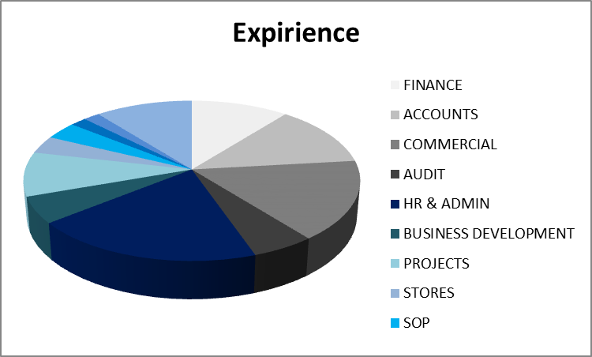

**CROSS DISCIPLINARY ROLES AT SUNDRY ORGANIZATIONS**

