[Akashrana444@gmail.com](mailto:Akashrana444@gmail.com)

AKASH RANA

MechanicalEngineer

Mechanical Engineer having an experience oF4 + production , quality maintenance, operations

□

+9189797792209/ 7037683703

**9**

Meerut, India

**SKILLS**

**B.TECH. (MECHANICAL**

**ENGINEERING)**

swami Vivekanand institute of Technology

2013-2017

Svsu

Meerut courses

**WORK EXPERIENCE**

**MECHANICAL ENGINEER**

MARUTI SUZUKI INDIALTd.

Gurgaon manesar 01/2018-01/2022

°Achievements/Tasks

Q PRODUCTION ENGINEER

Continuously improve machinery and provide engeneering support

* as need.

Plan, manage and perform product introduction.

° Devlop and implement cost reduction strategies, and dilever

quarterly improvement.

° Monitoring production process for new product line.

Maximize productivity and reduced production time cycle.

QUALITY ENGINEER

Assistant quality engineering managemet and other

functional manpower to implement and develop process o and product improvement

Analysis anand resolve work problem or assists workers in

* solving problems

MAINTENANCE

Operations and maintenance.

“ Prepraing maintenance schedules by implementing. ° modern maintenance system to ensure the

performance capacity oF various equipment.

Maintenance in stb ,wtp,solar plant,power plant, Floor reparing ,wall painting, fabrication.

Doing kyc ,3g,2g work permit ,saFtey traning For

workers,man power handling

Moter with hydraulic jack

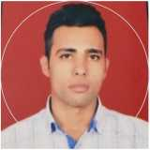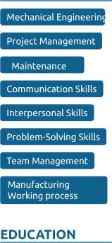

EDUCATION

AREA OF EXPERTISE

INTERMEDIATE

M.P. Board

*2012- 2013*

Production Quality Maintenance

STRENGTH

PERSONAL

DETAILS

Passport No.

***L5629291***

Date oF Birth: ***31/12/1992***

Nationality:

***Indian***

Marital Status: single

TRAINING

EXPERIENCE

*Company:*

**Perfect Sales corporation Rudrapur**

**Uttrakhand.**

*Location:*

Rudrapur .Uttrakhand.

*Duration:*

30 Days

**Working area:**

ManuFacturing and

Repairing (CT & PT),

Transformer Department.

n Good listener and positive attitude

SelF confident

□ Ablity to work in team

Ablity to do work under pressure

□ INTERESTS

Travelling Sports

LANGUAGES

° English Hindi

*Full Professional Proficiency Full Professional Proficiency*

I I II If