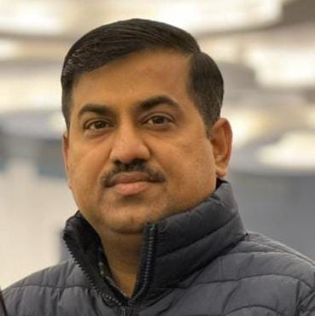 VIKRANT SHARMA
General Manager - Operations

 +91 8630367972
 vikrant_ajmer@yahoo.co.in
 https://in.linkedin.com/in/vikrant-sharma-528a0914

Profile Snapshot
22+ years of Professional Work Experience as an “Operations Expert” in Manufacturing Segment.

KEY SKILS:
Operations Management  Developing and Implementing Strategies  Effective use of Lean 6 Sigma | Staffing  Strategic Planning  Ensure Regulations are followed | Decision Making  Management  Maintain Budget and optimize Expenses  Evaluate Operational and financial performance

WORK Experience:

Period | Company | Company Logo | Designation | Company Turnover | Role
June 2023 - till date | AFI Feed Industries |  | GM - Operations | 400 Cr | Operations Head for Animal Feed Business of Company in India, Having 3 manufacturing plants in Khanna, Punjab. I am operating from Khanna, Punjab.
June 2022- June 2023 | IB Group |  | Head - Secondary Logistics | 8500 Cr | Head of secondary logistics of the group having turnover of 8500 crores., and was worked from Head Office at Rajnandgaon, Chattisgarh
Mar'2020-June 2022 | Mahindra HZPC (P) Ltd. |  | Manager - Logistics | 25000 Cr | Worked as Logistics Head for Pan India Operations in Potato Seed Division, Operated from Mohali H.O.
July'2019 - Mar'2020 | IB Group |  | AGM - Logistics | 8500 Cr | Worked as Logistics Head for North Region in Poultry Feed Division, Worked from Rajpura Plant.
June'2017 - July'2019 | Cargill India (P) Ltd. |  | Supply Chain Manager | USD 106 Billion | Worked as SCM Head for North Region in Animal Feed Division, Worked from Bathinda Plant.
May'2015 - June'2017 | Dayal Fertilizers (P) Ltd. |  | Supply Chain Manager | 500 Cr | Worked as Logistics Head for Pan India Operations in Fertilizer Division, Operated from Meerut H.O.
Nov'2009 - May'2015 | Godrej Agrovet Ltd. |  | Sr. Executive - Logistics | 8000 Cr | Worked as Regional Logistics Head for East Region in Animal Feed Division, operated from Kharagpur (W.B.) Plant.
June 2007 - Nov'2009 | Indiabulls Housing Finance Ltd. |  | Location Manager | 50000 Cr | Worked as location Head for Kolkata Location in Housing Loan division, operated from Kolkata Location.
Apr'2006 - June 2007 | ICICI Bank |  | Senior Officer | 125000 Cr | Worked as Relationship Officer for Ludhiana Location in Housing Loan division, Operated from Ludhiana Branch.
Oct'2002- Mar'2006 | Godrej Agrovet Ltd. |  | Finance Assistant | 8000 Cr | Worked as Store and Finance head for Ajmer Plant of Animal Feed manufacturing, Operated from Ajmer Plant

IT SKILLS:

MFGPRO, Tally, Windows, MS-Office – Excel, Power Point, Working on Google Drive etc.

EDUCATIONAL QUALIFICATIONS:
- MBA in Operations from SMU.
- Bachelor of Arts from Punjabi University.
- 4 days Management Development Program in Supply Chain Management from IIM, Calcutta
- 2 days Advanced Supply Chain Risk Management Program from International Institute of Business Intelligence
- Certificate in Computer Accounts and Taxation from S.T.E.P. – Guru Nanak Dev Engg. College Ludhiana
- Certificate in Store Keeping, from Building Centre, Thaper Institute, Patiala.

PERSONAL DETAILS:
Name : Vikrant Sharma
Father’s Name : Sh. Mohan Lal Sharma
Date of Birth : 14th Oct 1980
Marital Status : Married
Currant Address : Same as Permanent Address
Permanent Address : # 140, Kissan Enclave, Khanna 141401, District Ludhiana, Punjab, India
Mobile No :  +91 8630367972
Email Id :  vikrant_ajmer@yahoo.co.in

