Sharman Rice Changes

1.Check Space of Mountain Rice image overlap with text

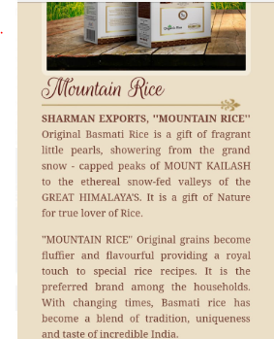

2.Remove all Text brand names only logo will be there

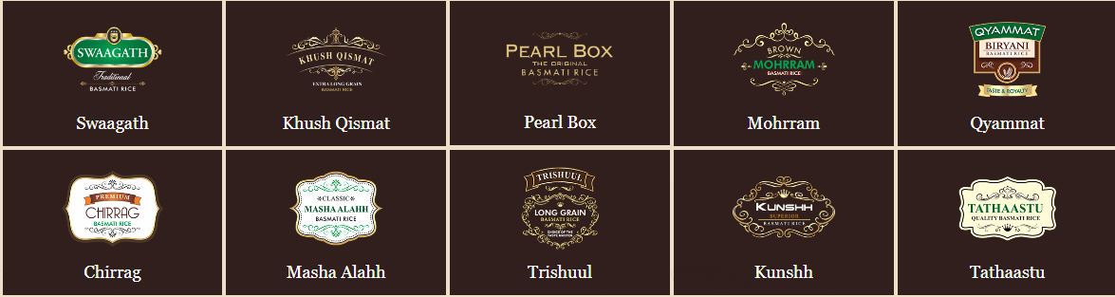

3. Video logo and text not formatted kindly check

