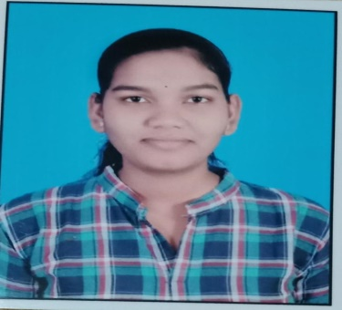

SEVATI DHRUW

Address : Mohtara, bemetara (491335 C.G)

Mob : 8830533551

Email ID : [sevatidhruw85@gmail.com](mailto:sevatidhruw85@gmail.com)

**CAREER OBJECATIVE**

To take up a challenging career and grow with honesty, loyalty, good relationship and best performance and utilize my works experience, knowledge, skills and abilities into value for an organization.

**ACADMIC QUALIFICATION**

|  |  |  |  |
| --- | --- | --- | --- |
| CLASS | BORAD | YEAR | PERCENTAGE |
| 10TH | CG Board | 2018 | 67.33% |
| 12th | CG Board | 2021 | 70.2% |
| Diploma | CSVTU ( CG) | 2021 | 75.8% |
| B.SC( computer) | PRSU ( Raipur CG) | pursuing |  |
|  |  |  |  |

**WORK EXPERINACE :**

* Designation :- Quality Assurance ( JS)
* Experience : - 3 Years
* Company profile :- Yokohama off highway tire (YOHT) in Vishakhapatnam (AP)
* I have 3 year (joining 2021 July 23 ) experience in process quality department (in tire building ) 9 month I am working in dahej plant .
* I am working as shift incharage on soft floor I handle the shifts independly.
* I have knowledge to other department like technical, NPD , & production etc.

**PROJECT :-**

During work have three project participants with team and work this project :

* One is belt scrap reduces.
* Reduction of GT/ carcass scrap.
* Cured rubber reduction

**COMPUTER SKILLS :-**

* MS – EXCEL : - Advance formatting ,charting , 7 Qc tools
* MS- PowerPoint:-Presentation slides Presentation MRM Reports .
* MS – Office: - types awareness.

**RESPONSIBLITIES :-**

* Verify that all quality related activities are in accordance and standard
* Responsible for preparing Quality plan that supports the project and client requirement on quality assurance.
* Provide independent quality control audit of client vendors.
* Ensure all QA/QC control measures and procedures are document, Implemented and auditable and fully comply with all client regulatory agency requirements. Preparation of NDT plan, NDT procedures and related Documents with reference to codes, standard and specification.
* Facing of internal audits as a ensuring CA/PA compliance to NC’s.

**Language:-**Hindi ,English

**PERSONAL PROFIL**

Father Name : ASHOK KUMAR DHRUW

Mother Name : SUNITA DHRUW

Marital status : Unmarried

Gender : Female

Religion : Hindu

Nationality : Indian

**STRENGTHS**:-

I am confident, disciplined have the ability to adapt to the available working environment, to work efficiently in a team and capability to produce time bound error free result

**Date –**

**Sevati Dhruw**