====================
CURRICULAM VITAe
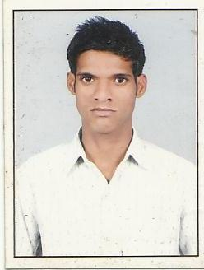
SHAMIM ANSARI

Father’s Name : Mr. MOINUDDIN ANSARI
Address : B3/72 Vishwa Bank A.D.A Colony Naini,
Allahabad (U.P)
Phone No : +91 9389712050
E-mail : sansari568@gmail.com

Career Objective:

To work in a challenging environment, demanding all my skills and efforts to explore and adapt myself in different fields, and realize my potential and contribute to the development of organization with impressive performance.

Professional Qualification:

I.T.I. 2007-2008 (Machine Tractor) from U.P. Madarsa Board Govt. of U.P.

Academic Qualification:

12th from U.P. Board in 2004.

10th from U.P. Board in 2002.

WORK EXPERIENCE:

- ESPIEM (Kirloskar Diesel Engine) Pvt. Ltd. From 2008-2010

- Two year Experience in Mitsubishi Genset post of Service Engg.

- I have 3 year Experience in BULL Construction equipment authorized dealer NARAYAN EARTH MOVERS Pvt. Ltd. Allahabad.

- 1st Aug. 2015 to till date. I am working G.S.Honda in Post of Floor Superviser in Naini Allahabad.

Computer Skills:

Fundamental of computer

Basic Knowledge of Internet.

Strengths :

- Time management & punctuality.
- Hard working and positive attitude.

Personal Profile :

Name : SHAMIM ANSARI

Father’s Name : Mr. MOINUDDIN ANSARI

Date of Birth : 05-Jan-1989

Marital Status : Married.

Sex : Male

Languages Known : English & Hindi.

Permanent Address: AL-14 A.D.A. Colony Naini, Allahabad
Pin Code: 211008

DECLARATION:

I hereby declare that the above written particulars are best of my knowledge and belief.

Date: SHAMIM ANSARI
Place:

