RESUME
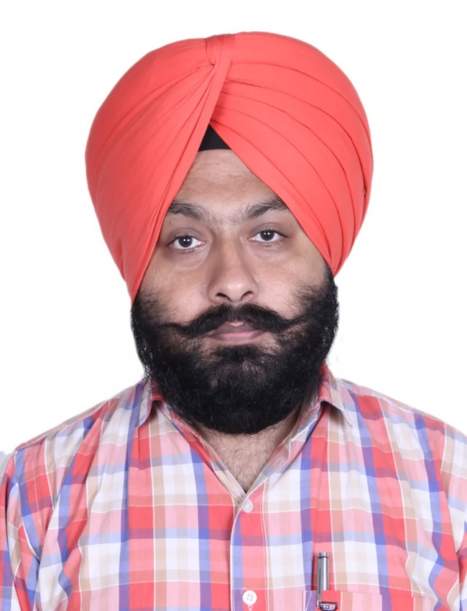

RUPINDER PAL SINGH BIRDI

House No. B-31, 1138/48A/1, Street No.2
Guru Teg Bhadar Nagar, Chandigarh Road
Ludhiana -141015, PUNJAB, INDIA.
MOBILE NO. +91-9781714547
birdi_rupinder@yahoo.co.in
birdi_rupinder@rediffmail.com

OBJECTIVE

Intend to build a career with leading corporate of high-tech environment with committed and dedicated people which will help me to explore myself for achieving organizational & individual goals.

Total experience in Electrical Operation and Maintenance is 16 years 9 months.

PRESENT COMPANY PROFILE

M/s SEL Manufacturing Co. Ltd. Rahon is the flagship company of SALUJA GROUP Ludhiana has established two big units of Terry Towel, two units of Spinning plant and two units of Open End plant

The company have two running Rice Husk based Co-Generation Power Plant having total capacity is 22MW (10MW+12MW) at RAHON near to NAWANSEHAR city Punjab.

PROJECT

Erection & commissioning of HT, LT control panels, Transformer, Motors and 70 TPH AFBC high pressure, high temperature Boiler Make: CBL & 12 MW extraction cum condensing Turbine Make: SIEMENS has been completed successfully on 22 March 2012.

PRESENT JOB PROFILE & RESPONSIBILITY (From 21 DEC 2010 to continuing)

- Presently Working as Sr. Manager Electrical and see the operation, maintenance and troubleshooting of all electrical equipment like:
- HT and LT Switchgear and Electrical control panels,
- AC VFD’s, Make: Schneider, ABB, SIEMENS, Danfoss
- LT ACB’s and HT VCB’s, Make: ABB and SIEMENS.
- 1- phase and 3-phase AC Motors, Make: Schneider, ABB, SIEMENS
- 11kV/415V Transformers of rating 3150kVA and 3500kVA,
- 11kV Alternators Make: TDPS,
- D.O.L starters and Star Delta starters, etc.
- Also check the routine parameters of both 10MW & 12MW Alternators on daily basis for smooth operation. As the both alternators are runs parallel synchronized.
- Operation & maintenance of RICE HUSK based high pressure Boilers and 10MW & 12MW Extraction cum Condensing Turbines (Make -SIEMENS).
- All auxiliary motors of boiler & turbine are runs on VFD’s and starters, which are operated from DCS (Distributed Control System) Make- YOKOGAWA & HONEYWEL.
- Operation, Maintenance and troubleshooting of ESP (Electrostatic Precipitator)
- Dense phase ash conveying system for ash handling. (Make- OSM Engineering)
- Overall responsibility of the power plant to maintain and generate electricity with manpower and resources available.

ACHIEVEMENTS

- Minimize the motor burning rate successfully by using preventive and predictive maintenance schedule of all motors and its VFD’s and starters panels.
- Increase in overall plant production by minimizes the plant breakdowns by using preventive and predictive maintenance schedule.

PREVIOUS COMPANY EXPERENCE: 5 Years 3 month from Sept. 2005 to 20 Dec. 2010

PREVIOUS COMPANY PROFILE

M/s OSWAL WOOLEN MILLS LTD. (OWM) is an ISO 9001-2000 certified the flagship company of Nahar Group of Companies Ludhiana is manufacturing of all type of Blended Worsted, Lambs Wool, Knitting and Weaving Yarns. Also company has 3.5MW Rice Husk based Co-generation Power Plant.
The company has leadership in Woolen Garments, Sweaters & Cardigans with its leading brands MONTE CARLO & CANTERBURY in India.

PROJECT

- Erection & commissioning of HT, LT control panels, Transformer, Motors and rice husk based 3.5 MW Co-generation POWER PLANT in M/s Oswal Woolen Mills Ltd. (Nahar Group of Companies) Sherpur G.T Road Ludhiana, Punjab.

JOB RESPONSIBILITY in previous company

- Worked as Sr. Electrical Engineer from Sept. 2005 to Dec.2010.
- Here my job profile was to see the operation, maintenance & troubleshooting of all Electrical equipment like 11 kV Alternator (Make- BHEL), AC VFD’s (Make-Siemens, ABB & Denfoss), ACB’s (Make-Siemens), HT VCB’s (Make-Siemens), 3-phase AC Motors, 1500 kVA Transformer, all LT and HT control panels, D.O.L starters and Star Delta starters, etc.
- Operation & maintenance of 25 TPH AFBC high pressure Boiler and 3.5 MW Extraction cum Condensing Turbine.
- Operation of Boiler, Turbine and all its auxiliary motors operated through DCS (Distributed Control System) Make- YOKOGAWA
- Operation, Maintenance and troubleshooting of ESP (Electrostatic Precipitator)
- Dense phase ash conveying system for ash handling. (Make- MACWBARE BEE KAY)

INDUSTRIAL TRAINING

- Six month industrial training at 220 kV substation Lalton Kalan, Ludhiana under Punjab State Electricity Board (P.S.E.B.).
- One month industrial training at Crystal Electric Ltd. Focal Point, Ludhiana.
- Training of DCS- Centum-1000 R3 (Distributed Control System) by YOKOGAWA engineer at Oswal Woolen Mill Ltd. Ludhiana.
- Attend the training program on Industrial Safety in Textile and General Engineering Industries at M/S Vardhman Yarns & Threads Ltd. Unit-2 Ludhiana organized by Directorate of Factories, Punjab.

EDUCATION

- BE / B-Tech (ELECTRICAL ENGINEERING)

Engineering degree in Electrical branch from Shaheed Udham Singh College of Engineering & Technology, Tangori, Mohali, Punjab, affiliated to Punjab Technical University, Jalandher pass out in May 2005.

COMPUTER KNOWLEDGE

- Five month Computer Diploma in Computer Programming from Guru Teg Bahadar College of Information Technology, Ludhiana.
- Basic Fundamentals of Computers
- Worked on Windows 98, 2000, XP, Window 7, Window 8 & Window 10.
- Sound knowledge of MS Office and WPS Office.
- Sound knowledge of INTERNET surfing for data communication and data transferring through E-mail.

PERSONAL INFORMATION

Date of Birth : 22nd March, 1981
Father’s Name : S. Dharm Pal Singh Birdi
Father’s Occupation : Retired as Science Teacher
Nationality : Indian
Marital status : Married
Languages known : Punjabi, English, Hindi.
Hobbies : Playing Cricket, Singing and Listening Soft music.
___________________________________________________________________
SALARY
Current CTC : Rs. 8.40 Lakh per year
Expected Salary : Negotiable

DECLARTION

I hereby declare that the above mentioned information is correct to the best of my knowledge.

RUPINDER PAL SINGH BIRDI

