**CURRICULUM VITAE**

PERSONAL DETAILS

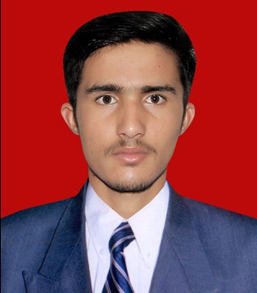

**Name**: Dinesh Bairad

**Father’s Name:** Babu lal

**Mother’s Name**: Rampyari

**Date of Birth**: 2 Oct 2002

E-Mail:

[bairaddinesh2002@gmail.com](mailto:bairaddinesh2002@gmail.com)

Mobile:

9521131088

**Address:**

Bairdo ki dhaniya,Kharda Mewasa

Jodhpur, (Raj.)

Pin – 342305

CAREEROBJECTIVE

Looking for a challenging career which demands the best of my professional ability in terms of, technical and analytical skills, and helps me in enhancing my current skill and knowledge.

EXPERIENCE

Nihon Parkerizing India Pvt. Ltd

Diploma Engineer Trainee

( 4 Jan 2021 to present )

JOB RESPONSIBILTIES

* Batch reactor check point monitoring
* Responsible for hard base and acid handling
* Responsible for raw material management as per job task
* To control heating and cooling system as per SOP
* Product packaging labelling and monitoring up to the final product
* To maintain 5s system in job responsibility area. (As 5S incharge)
* To maintain safety standard as per protocol.

EDUCATION

|  |  |  |  |  |
| --- | --- | --- | --- | --- |
| **Examination** | **University/Board** | **Institute** | **Year of Passing** | **Percentage** |
| 10th | CBSE | Swami Vivekanand Government School | 2017 | 62.70 |
| Diploma(Chemical Engineering) | BTER | Government Polytechnic College Barmer | 2020 | 64.14 |

MAJOR PROJECT

Working Modal of Bio gas fuel plant.

TRAINING

**Company**: Rainbow Paints and Chemical Pvt. Ltd

**Duration**:24 days (12th April 2019 to 6 May 2019)

**Place**: Jodhpur

**Area of Training**: Testing of paints and complete manufacturing process.

SOFT SKILLS

**MS Excel, MS word, MS Power Point.**

EXTRA-CURRICULAR ACTIVITIES

* Managed agriculture shop of fertilizer , Pesticide and Seeds
* **Soil** testing

HOBBIES

I like gardening and Listening music.

**Declaration:**

I hereby declare that the information provided here is truly to my knowledge.

**Date:**

**Place:** Jodhpur **Dinesh Bairad**