CURRICULUM VITAE

MANDEEP SINGH  Bathinda Punjab.  Mobile No:+91-7814776610  e-mail : ermandeepsingh3186@gmail.com | 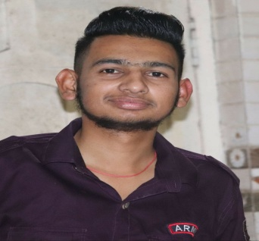

PERSONAL PROFILE
Nationality | : | Indian
Current Address | : | Bathinda Punjab.
Language Known | : | English,Hindi,Punjabi(Read,Write and Speak)
Total Working Experience

I have an experience on 3.5 years and I have theortical knowledge as well as Practical knowledge I can do hard work for my Organisation and I will put my all efforts for good process of organisation.
Proficient In : Tyre Testing at Research & Development Center(CEAT TYRE).

Currently working in sales and marketing from last 1 year.

CARRIER OBJECTIVE

- Looking for rewarding and challenging carrier in service industry as Test Engineer where a professional environment can equip me with knowledge and give me space for innovation and creativity to discharge my responsibilities.

- My short term goal is to join your Organisation and Enhance my Skills and My long term goal is to see Organisation at Peak level when I am of the person responsible for it.

PROFESSIONAL QUALIFICATION

- Having Knowledge Of All Types of Indoor Tyre Testing .
- Knowledge Of All Types Of Tyre Testing Standards.
- Knowledge Of Machine Maintenance, Calibration & Equilibration.
- Familier with MS OFFICE.
- Knowledge Of SAP & MIGO.

EDUCATIONAL BACKGROUND (ACADEMIC)

- DIPLOMA IN ELECTRICAL ENGINEERING (2014-2017) With 71% Of Marks From GPC Bathinda, Punjab.
- Matriculation in PSEB (2014) with 75% Of Marks.

TRAINNING

- I have done 45 days Internship At GURU NANAK DEV JI Thermal Plant Bathinda, Punjab.
- I have also done Trainning on FIRST AID and FIRE FIGHTER.

WORK EXPEREINCE

- Perform All Tyre Categories (PCR, MC, TBR, TBB, LT) Testing (Rolling Resistance, Endurance, High Speed, Stiffness, Foot Print, Teckscan, Bead UnSeating, Plunger, Bead Compression, Tire Profile, Dynamic Bead Unseating, Tire Dimensions, Hydro Burst, Ageing Oven, Pinch Cut).
- Perform Calibration & Equilibration of Machines.
- Making Shift Schedule Of Associates as well as ITI Holders.
- Perform Preventive Maintainance.
- Develop KAIZEN in working Area.
- Maintain 5S & Safety Environment.

ADDITION & STRENGTH

- Promote awareness and commitment to focus on job delivery deadlines, quality as well as cost.
- Efficient job planning & time scheduling.
- Work with Dept. manager, senior engineer to support Their Projects.
- Any other tasks as and when assigned by manager/management.
- Very good communication and team working skill.
- Willingness to work in overtime and take over to new/supplementary task.

HOBBIES & STRENGTH

- Singing & Playing Cricket.
- I can adapt easily in any type of environment.
- Quick Learner.
- Good Communication Skills.

DECLARATION

I hereby declare that all informations are true, correct to the best of my knowledge and belief.
I hope you will consider my CV favourable and call me for an Interview with the delegate and prove my worthiness and capabilities. I shall be ever grateful to you at all time.

Thanking you Your faithfully,

Mandeep Singh

REFERENCES

- Personal and professional references shall be furnished on request.

