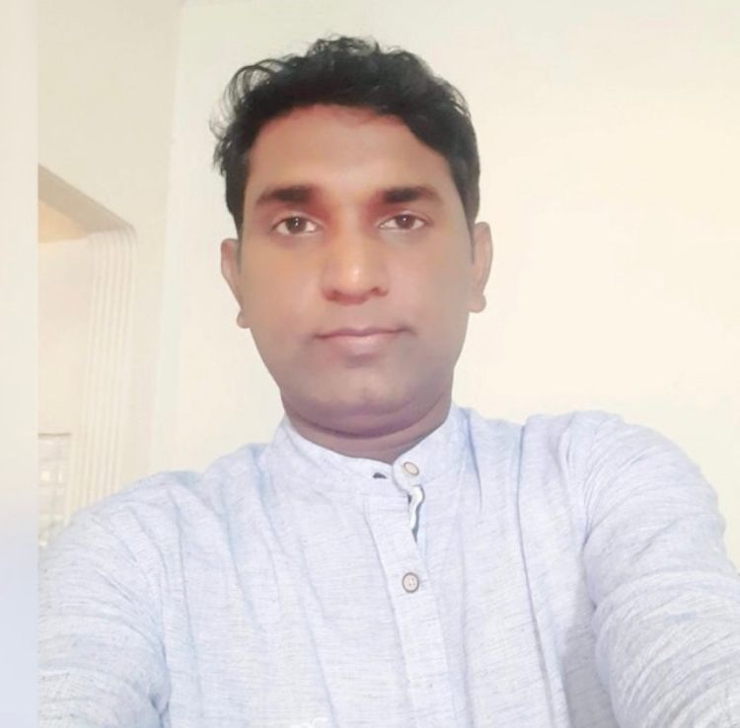
Bansi Lal Patel
E-Mail: patelbansi1983@gmail.com
Phone: +91 9973514075 / +91-8595113636
Address: Prayagpur (Sobari), Nahawai, Prayagraj - 212306

Result-oriented Professional, targeting challenging assignments in All greenfield, brownfield Projects / Construction Operations / Coordinate & Execute Civil Infra Projects across multiple Maintenance Operations with a growth-oriented organization of repute in EPC, Manufacturing sector, preferably in PAN India

SKILL SET  Project Management  Civil Engineering Operations  Site Administration  Execution & Handing Over  Construction & Maintenance  Process Engineering  Team Management  Vendor Management  Process Safety Management | PROFILE SNAPSHOT  - Dy Manager – (Project & Civil Maintenance) with more than 15 years of experience in Civil Engineering Construction execution, greenfield, brownfield Projects & with Coordinate & Execute Civil Infra Projects across multiple. locations pan India maintaining time, safety & quality standards to facilitate operations. Maintenance in the EPC/ Construction & Manufacturing sector.  - Track record of successful completion of projects, worth millions, by developing a positive rapport with architects, engineers, vendors & clients and controlling costs; flair for adopting modern construction methodologies/techniques in compliance with quality standards  - Skills in using the latest engineering tools and cost evaluation techniques to produce cost-effective solutions & preparing the monthly Reconciliation Statement of Construction materials.  - Excellence in executing the entire project right from scratch to its completion.  - Expertise in planning & executing construction projects with a flair for adopting modern construction methodologies; complying with quality standards.  - Appreciated for managing multiple projects and milestones while ensuring projects complied with all the cost and scope specifications.  - An enterprising leader with proven dexterity in directing personnel towards accomplishment of a common goal

ORGANIZATIONAL EXPERIENCE

Since May ’22 with ALP Nishikawa Limited at Gurugram as a Dy Manager (Project & Civil Maintenance) – Project Engineering coordinator with site execution of All greenfield, brownfield Projects & Plant Maintenance - Deferent type of Industrials Construction PEB & Civil Structural Building & exiting Plant & Maintenance and renovation work pan India plants. – ALP Nishikawa Co. Pvt Ltd our flagship company is a joint venture between the ALP Group of India and the Nishikawa rubber co. ltd of Japan. ALP Nishikawa for the last 20 years is a dedicated OEM supplier to most Global Automotive Manufacturers in India.

Handling of Projects - Engineering with Construction and Coordination of Greenfield Projects & Plant Maintenance with Interiors work –. In India deferent location Project & Plant in Gurugram, Gugalkota (Nimrana) & lalru- Punjab & Ahmadabad Sanand & Nasik, Project & Maintenance.
April ’16 to ’5 May 2022 with Timarpur Okhla Waste Management Co. Ltd (Group of Jindal Saw Ltd.) Waste to Energy Power Plant, New Delhi as Asst. Manager – Civil Projects:
Operational Plant & Maintenance -- 23MW Waste to Energy operational Civil maintenance Plant & Construction& demolition Chimney and other modification of plant building, waste Collection processing, segregation & disposal, construction, sanitary landfill, and Execution of FGCS & 60m height Chimney, 332 KLD Leachate Treatment Plant, Rainwater Harvesting System & Underground HDPE Pipeline installation and other construction work in running Plant associated to operational maintenance of the WtE plant.
Project: - I - 25MW Waste to Energy Power Plant -Tehkhand Waste to Electricity Project Limited, New Delhi
Highlights: Execution /Construction Waste to Energy Main Plant Area & Water system (WTP) 720 KLD Plant & Boiler ACC TG, Elevated Bridge Rump. Etc
Project- II-12 MW, Jindal Urban Waste Management (Jaipur) LTD & Jodhpur – Survey & Execution, development of green field Land /Projects for plant & sanitary landfill Area, fencing/ boundaries & communication with related Urban Municipal corporation, & documentation for land lease. of WtE Project etc.
May’12 to Mar’16 with BGR Energy Systems Limited, Chennai as Sr. Engineer (Civil)
Projects:
- I-Project: 1000 MW (2x500MW) Thermal Power Plant at Marwa Tendubhata Thermal Power Project, Marwa Dist., Janjgir - Champa, Chhattisgarh - EPC Contract of BOP Package, awarded by Chhattisgarh State Power Generation Co Ltd, (CSPGCL) worth Rs. 1633 Crore.
- II-Project: 2x300 MW Thermal Power Plant at TRN Energy Ltd, Nawapara Village, Dist – Raigarh, Chhattisgarh - EPC Contract Awarded by TRN Energy Ltd worth 2050 Crore.
Feb’11 to Apr’12 with KSK Energy Venture Limited, Bilaspur as Engineer (Civil)
3600 MW (6x600MW) Thermal Power Project at KSK Mahanadi Power Company Ltd, Nariyara Village, Akaltara, Dist: Janjgir – Champa, Chhattisgarh.
May’07 to Jan’11 with Abhijeet Corporate Power Ltd, Ranchi as Engineer – Civil
1st Unit (2x270 MW) & 2nd Unit (2x270 MW) in Latehar District in Jharkhand.
Aug’05 to Apr’07 with S.P. Builders Ltd, Jabalpur as Jr. Engineer - Civil
Projects: Execution of Multi-storey Building Constructions (G+3) Road, Drain & Sewage Treatment Plant (350 KLD) awarded by Ircon International Co. Ltd. for Defence Housing, Allahabad
Role: (Across the tenure)
- Supervising civil work BTG & BOP Area Equipment Foundation, Bottom Ash System, Seal Air PA Fan, FD Fan ESP , FGCS , Including all Duct Sport Foundation BFP, CE Pump Foundation & Switchyard Transformers foundation Including Cable Trench, Wall, DG Building, Compressor House ID Fan Duct Sport Foundation & Area Grade Slab, Pipe Pedestal Foundation Water System Clarifier & Service Building & Plant Internal Road & Drainage System
- Executing civil work for 220 KV & 400 KV Switchyard Tower, & Equipment Foundation & Switchyard Control Building, Cable Trench & including ICT Transformers Foundation, & CW Pump House Forebay, Water Treatment Plant & Chemical Building, D G Building, Coloration, Building & Fire Fighting Pipe Line Excavation, construction of Pipe Rack / Sport Pedestal, CHP Track Hopper, Tunnel & Fly Ash Silo, Utility Building
- Developing project baselines; monitoring and controlling projects with respect to cost, resource deployment, time over-runs and quality compliance to ensure satisfactory execution of projects
- Land Development Analyse survey reports, maps, drawings, blueprints, aerial photography, and other topographical or geologic data to plan projects, Supervision and support to the construction, processing facility and other civil works.
- Formulating operating budgets & managing overall operations for executing civil projects within cost and time norms; organizing / participating project review meetings for evaluating project progress and de-bottlenecking
- Anchoring on-site construction activities to ensure completion of project within the time & cost parameters and effective resource utilization to maximize output; understanding detailed structural designs and preparation of structural drawings for the plant
- Managing the preparation of monthly progress reports, DPR preparation, work on schedule, entailing progress and details for engineering, procurement, construction and commissioning activities, Devising the detailed and abstract estimates, bill of quantities, alignment plans, longitudinal and cross-sectional drawings, completion of work on schedule and plan
- including cross and longitudinal profile correction
- Coordinating with external agencies for techno-commercial negotiations, preparation of tender / contract documents, cost estimates, including billing, variation / deviation proposals, claims, so on.
- Maintains safe and clean working environment by enforcing procedures, rules, and regulations.
- Maintains and ensures safety standards at all stages of construction work.
Significant Accomplishments:
- Initiated the timely execution of 220 & 400KV Switchyard & Water System project within budget; implemented cost control strategies and effective estimates for site infrastructure.
- Coordinated with contractors for completing work on time and collaborating with stores for material supply, follow-up on drawings with planning team, preparing running account bills for the payment to contractor, coordinated for maintaining and assuring quality with the Quality Control Team
- Initiated safety week and guided the manpower regarding safety measures to be taken while working.
- Managed the construction & widening for 3 Nos. projects for KSK Energy, CSPGCLY & TRN Energy.

ACADEMIC DETAILS

2009 B.E. (Civil) from NIIBMT, Delhi
2005 Diploma in Civil Engineering from Govt. Polytechnic, Basti
IT SKILLS
- Computer Fundamentals
- MS Office (Excel, PowerPoint & Word)
- PageMaker, Corel Draw, Photoshop
- Software Package: MS Project, AutoCAD & SAP R/3 MM PS
PERSONAL DETAILS
Date of Birth: : 2nd January 1983
Languages Known: : Hindi & English
Passport No : N6198559

PRESENT C.T.C : 16 Lacs/Year
Expected C.T.C : Negotiable

DECLARATION.
Above Details are true to the best of my knowledge and belief.
Date: …...
Place….... (Bansi Lal Patel)

