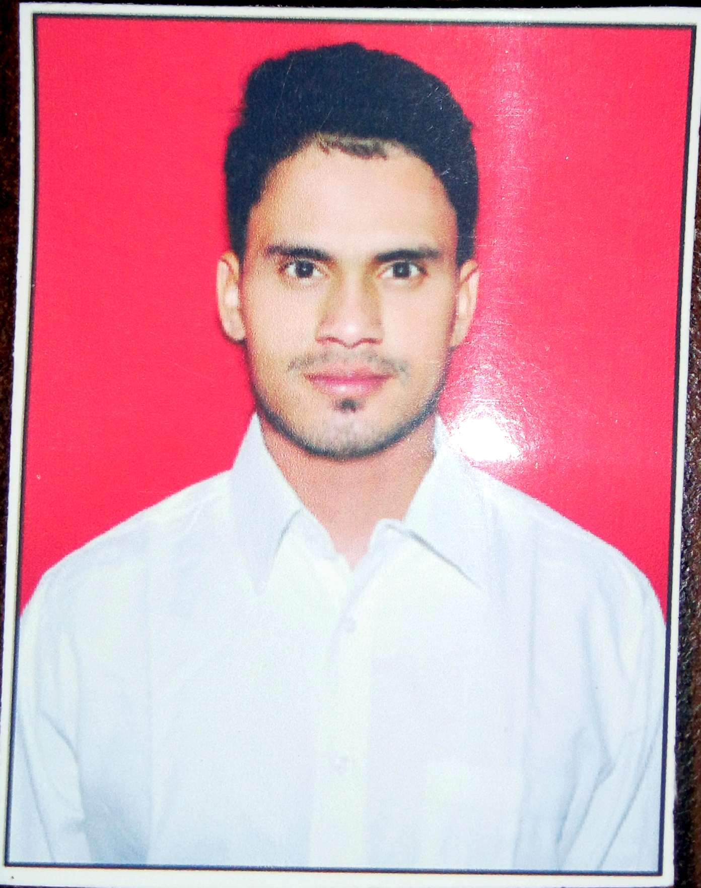**RAKESH KUMAR**

**CURRICULUM VITAE**

**University: Residential Address:**

**PANJAB UNIVERSITY (CHANDIGARH)** PLOT NO.- 241

Guru nanak colony,

Dhandari kalan, Ludhiana.

Punjab

Pin: 141014

**Email:** rsrakeshsingh071@gmail.com

**Contact:** +91-8054660062

**OBJECTIVES**

Intend to build a career with leading corporate of hi-tech environment with committed and dedicated people, which will help me to explore myself fully and realize my potential.

**EDUCATIONAL CREDENTIALS**

**CLASS – M.COM**

**SHREE ATAM VALLABH JAIN COLLEGE**

**RESULT**

Passed by securing **77.89%** marks  **2015-2017 USOL (CHANDIGARH)**

**CLASS – PGDCA**

**(POST GRADUATION OF DIPLOMA IN**

**COMPUTER APPLICATION)**

**GURU NANAK NATIONAL COLLEGE**

**RESULT**

Passed by securing **66.5** % marks **2014-2015 PANJAB UNIVERSITY**

**CLASS -B.COM**

**GURU NANAK NATIONAL COLLEGE**

**RESULT**

**Passed by securing 55.76 % marks 2011-2014 PANJAB UNIVERSITY**

### CLASS -12TH

**RAMGARHIA Sr. Sec. School 2011 P.S.E.B**

**RESULT**

Passed by securing **60.9** % marks

**CLASS -10th**

**S.G.D. Sr. Sec. School 2009 P.S.E.B**

**RESULT**

Passed by Securing **71.76** % marks

**PERSONAL DETAILS**

Date of Birth : FEBRUARY 22ND, 1993

Father’s Name: Mr. UMESH SINGH

Mother’s Name: Mrs. KAVITA SINGH

Nationality : Indian

Marital Status: Married

**EXPERIENCE**

**6 YEARS 4 MONTHS EXPERIENCE AS A SENIOR ACCOUNTANT AND TAX EXECUTIVE ( AT EASTMAN INTERNATIONAL). FROM 06.03.2018 to TILL DATE.**

**3 YEARS EXPERIENCE AS A SR. ACCOUNTANT. ( AT PRECISION INDUSTRIAL FASTENERS). FROM 01.03.2015 to 05.03.2018.**

|  |  |
| --- | --- |
| **JOB DESCRIPTIONS** | |
| **SR. NO.** | **PARTICULAR** |
| 1 | BANK BOOK UPDATE INCLUDING:- |
| CHEQUE ISSUE & RECEIVE |
| UPDATE BANK BOOK & PASS BOOK |
| ADJUST PAYMENT ADVICES |
| 2 | UPDATE TDS DETAILS MONTHLY WITH ALL ENTRIES. |
| 3 | PREPARE AND DEPOSIT PROFESSIONAL TAX MONTHLY. |
| 4 | PREPARE TDS RETURNS MONTHLY. |
| 5 | RECONCILE ALL ACCOUNTS STATEMENTS. |
| 6 | PREPARE BALANCE SHEET AND PROFIT & LOSS |
| 7 | PREPARE GST RETURNS MONTHLY LIKE GSTR1, GSTR3B ETC. |
| 8 | INCOME TAX RETURNS PREPARE AND FILING FOR ALL EMPLOYEES AND FIRMS AS WELL AS ALL CO’S. |

**PROJECT REPORT**

Project report on "**THE TREND ANALYSIS OF FINANCIAL STATEMENT".**

**ACHIEVEMENTS**

* **GOLD MEDAL** IN BEST PHYSIQUE INTER COLLEGE UNIVERSITY COMPETITION **(CHANDIGARH)**
* **BRONZE MEDAL** IN BEST PHYSIQUE INTER COLLEGE UNIVERSITY COMPETITION **(CHANDIGARH)**
* **SILVER MEDAL** IN BEST PHYSIQUE INTER COLLEGE UNIVERSITY COMPETITION **(CHANDIGARH)**

**STRENGHTS**

* Hard cum smart working.
* Want to enhance my skill through my performance.
* Flexible to work at any environment.
* Good leadership.

## TECHNICAL SKILLS:

|  |  |
| --- | --- |
| **Operating Systems** | * Windows XP, Windows 7 / 8,Wsindows 10 |
| **Programming Languages** | * C, C++,TALLY PRIME, ORACLE, KDK SPECTRUM |
| **skills** | * GSTR, Income Tax, TDS, Balance Sheet, MS office, bank reconciliation. |

**KEY-SKILLS**

* Fast Learner.

* Tally Prime & KDK Spectrum for income tax & T.D.S. Returns.

* Thinking skills (problem solving and decision making)

* Any other responsibility assigned by my seniors.

**Declaration**

I hereby declare that the above- mentioned information is correct up to my knowledge and I bear the responsibility for the correctness of the above- mentioned particulars.

**Date..................**

**Place - Ludhiana**