VENKATESAN NATARAJAN
venkat.n2010@gmail.com

N. VENKATESAN
No;53B, M S Garden, nalleeswarar nagar
Thirumanam village,
Pattabiram, Chennai-600072
Mobile: 8072656280/9043494186
Email: venkat.n2010@gmail.com

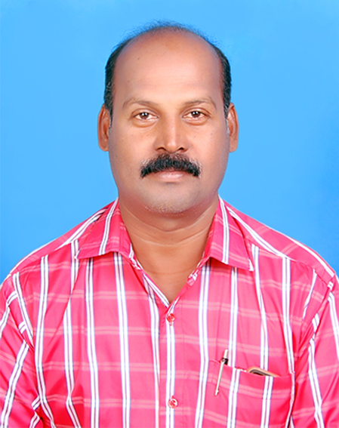

Objective

To be an Good Management professional in the dynamic world of competition, where I can contribute my expertise for the company’s growth and individual development. I have been an asset to every company I have worked for.

Industry Exposure

AUTOMOTIVE INDUSTRY MARKETING/ SALES/SERVICE ,
DEALER, DISTRIBUTION CHANNEL MANGEMENT
KEY FLEET MANAGEMENT
PROMOTIONS ACTIVITY.FOR DEALERS & DISTRIBUTORS
CUSTOMER SERVICE, OEM SERVICE TECHNICAL TRAINING

- AGARWAL RUBBER LIMITED Jan 2022 to Apr 2023
- REGIONAL MANAGER ( Tamilnadu)
- (Automotive (2&3&4 wheeler tyres and tubes)
- Appointing Distributor/Handling team
- Dealer channel/Team Handling

- ELGI RUBBER COMPANY LTD 2020 Jan to jan 2022
- BRANCH MANAGER – Retreading Plant
- Sales Team Handling and target/inventry
- Over all branch operation profit control
- Truck and Lcv tyres Retreading /Retail sales
- Fleet/Key accts/Retail/stocks managing
BALU IRON AND STEEL COMPANY
Area Sales Manager - chennai 2018 Dec TO 2020 Jan
( JSW STEEL – TMT/COLOURN ON SHEET)

- CEAT LTD.
- TERRITORY MANAGER ( SALES) 2010 May TO 2017 Dec
- Chennai Region
COMMERCIAL VEHICLE TYRES - TRUCK/LCV/Farm/PCR/OTR/TW
- Responsibilities;
- Distribution & Dealer channel management.
- C&F Chennai and Pondicherry depots covering 6 districts below
- Chennai, Vellore, Pondy, Tiruvannamalai, Villupuram & kallakuruchi.
- Responsible for Sales, dealer Management & new market development.
- Inspection of service failed tyres and timely solution to end users
- CFA handling for stock Inventry FIFO
- Dealer improvement plan with action.

- BEST TERITORRY MANAGER (SALES) AWARD - 2012

- All OEM – ( ASHOK LEYLAND, TATA,FORCE MOTORS, SWARAJ TRACTORS,EICHER ,BHARAT BENZ, /FLEET MANAGEMENT
- TYRE MANAGEMENT
- OEM- TECHNICAL TRAINING GIVEN/TYRE MAINTANANCE/CUST HANDLING

- BEST TERRITORY MANAGER CUSTOMER SERVICE AWARD - 2014

- BIRLA TIRES 2008 May TO 2010 Mar
- SALES ENGINEER
- TRUCK/LCV/PCR/FARM/OTR/TW - DEALER MANAGEMENT
- Covering entire NORTH ARCOT DIST.
- Vellore/ Thiruvanamalai / Tirupathur/ Vaniyambadi
- SALES AND SERVICE CLAIM
- Key account management/Technical training

- BEST SALES ENGINEER – SOUTH, - SALES CHAMPION AWARD - 2010

- Responsibilities:
- Team handling/ CFA handling for north arcot district
- Demand generation of PCR/TRUCK/LCV/OTR/TW/FORM
- Educating the fleets on better Tyre Maintenance and usage of Tyre for Repair/Retread.
- Execution of events like Sales promotional meets, product launches
- Appointing new Dealers. Key fleet accounts handling

- .WALCLADD INDIA PVT LTD 2005 mar to 2008 apr
- AREA SALES MANAGER
- PONDICHERRY
- ACP sheet( Aluminium composite sheet)
- Wall cladding, and glazing
- TVS. SUNDARAM INDUSTRIES LTD., 2000 Apr to 2005 Feb
- Tyre solution Division - Asst Manager Sales
- Team Handling - TRUCK/LCV/Farm/OTR
- Commercial vehicle tyres Retreading
- Covering; north and south, Entire Chennai

- GENERAL TIRE RETREADING CORPORATION PVT LTD 1995 Apr to 2000 Mar
- Sr.SALES OFFICER
- TRUCK/LCV/ALL Commercial vehicle tyres Retreading.
- B.B.A (Batchler of Business Administration.)
- University of Madras – 2007 YEAR

TECHNICAL QUALIFICATION:
- Diploma in Computer application(D.C.A
- SAP, WORD, EXCEL , TYPING-HIGHER

PERSONAL DETAILS

- Date of Birth : 08.10.1970
- Father’s Name : E. Natarajan
- Martial status : Married
- Languages Known : Tamil/English/(Hindi-manage)
- Contact Mobile : 8072656280
- Current C.T.C : 9.80 lakhs
- I hereby declare that all the information given by me are true to the best of my knowledge.

                - [N.VENKATESAN.]

