|  |
| --- |
| RESUME |

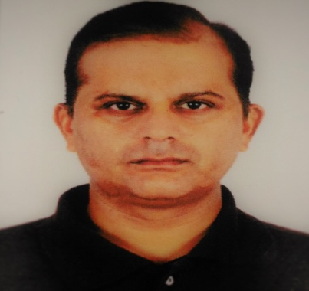

AJAY KUMAR JADLY

**H.No.C-9 FIRST FLOOR**

**Ganesh Township Society,**

**Sharwan Choukadi,**

**Bharuch. GUJARAT**

**Mobile: 09639932714/09904629875**

Email:**ajayjadly@yahoo.co.in**

**:**[ajadly1@gmail.com](mailto:ajadly1@gmail.com);

## A Hardworking, Pro-active Purchasing Person with an upbeat and positive attitude. Result oriented and able to use initiative to develop effective solutions to supply chain problems, while having an active and dynamic approach to work and getting things done efficiently.

# KEY SKILLS & ABILITY

* Having strong oral and written communications skills.
* Effective interpersonal skills in forming and maintaining effective working relation with Vendors.
* Ability to establish and maintain effective working relationship with employees at all levels.
* Considerable knowledge of Purchasing and proven ability to reduction in Cost.
* Vast Experience of work with range of suppliers.
* Excellent judgment and team coordinator

# EDUCATIONAL QUALIFICATIONS

* MBA from Punjab Technical University in 2014.
* Graduation (BSC) from Garhwal University in 1994.
* Intermediate from U.P.Board in 1990.
* High School from U.P.Board in 1988.

# PROFESSIONAL QUALIFICATIONS

* One-Year Diploma Course in Computer Software.
* Having Knowledge of Material Management.
* Having knowledge of Letter Drafting.
* Knowledge of Financial Package Tally.
* Knowledge of SAP as well as ERP.

# WORK EXPERIENCE

##### Current Organization: Alliance Tire Group, (A YOKOHAMA GROUP COMPANY) Dahej, Dist. Bharuch, Gujrat (Since April 2015 to till date)

**DEPUTY MANAGER-PURCHASE**

* Looking after procurement of all machinery spare parts e.g. Bearing, Cables, DG Spares, V-Belts, Compressor Spares and other utility related Consumables.
* Looking after Purchase of Coal, Project material & production consumables as per requirement of the departments.
* Arranging Engineering Spares as per Min-max Stock items.
* To keep all documentation of Audits and Departmental Reviews.
* Preparation of comparative chart and negotiations with the vendors and select existing ones for good prices and quality.
* To ensure monthly schedule of the material to the respective vendors and suppliers for delivery in time.
* To ensure issuance of timely purchase orders to all related vendors and suppliers to avoid the delay in delivery of the material.
* Ensure to follow Purchasing Procedures as per SOP. Material planning to ensure timely receiving of all material to run the smooth production line and review the daily, Handling Coal Purchase and reviewing daily stock.

##### 2. Birla Tyres (Laksar)

##### (a) Designation: Purchase Officer

###### Since November 2007 to March 2015

***­­­­***

***Job profile***

1. Preparing quote comparative chart and Negotiation with the suppliers and select adequate supplier for good pricing and favorable payment terms.
2. Purchasing Mechanical, Electrical, Utility and Consumable items.
3. Prepare & Finalization Purchase Orders, as per Purchase Requisition/Schedule Plan.
4. Sourcing & Developed New Vendors for Engineering & others Items. Working with SAP/ORACLE systems. Prepare & Finalization Purchase Orders, as per Purchase Requisition/Schedule Plan.
5. Opening new codes for vendors & material in oracle
6. Assurance for minimum delivery time & good quality of products.
7. Coordination with various departments like Personal, Administration & Maintenance Workshop.
8. Planning out source material requirement on monthly basis.
9. Coordinating with Out-source Parties and transporters for timely Delivery.
10. Coordinating with Finance for timely payment also.

**3. Madhuban Academy of Hotel Administration & Research (MAHAR**) (D.Dun) Since April 2000 to November 2007

* Procurement of all FMCG on day to day basis.
* Vendor Development.
* Floating Enquiries and making Comparative statement.
* Negotiations with vendors and raising Purchase Orders, selecting after hard negotiations.
* Coordinating with accounts dept for timely payment.
* Inventory reconciliation and maintain FIFO.
* Looking all administrative work (including housekeeping, welfare, canteen, Liasoning etc.)

# PERSONAL DETAILS

Father’s Name : Sh. Mahesha Nand Jadly

Date of Birth : 25.05.1973

Marital Status : Married

Permanent Add : Vill: Chiwonwali, PO-Kandoli, Dehradun-

Pincode-248001

Hobbies : Making Friends & Listening to Music

# Other Details

Expected Salary : Negotiable

**DATE:** **(AJAY K.JADLY)**

**PLACE:**

**BHARUCH**