**CURRICULUM VITAE**

**RAVI SINGH** 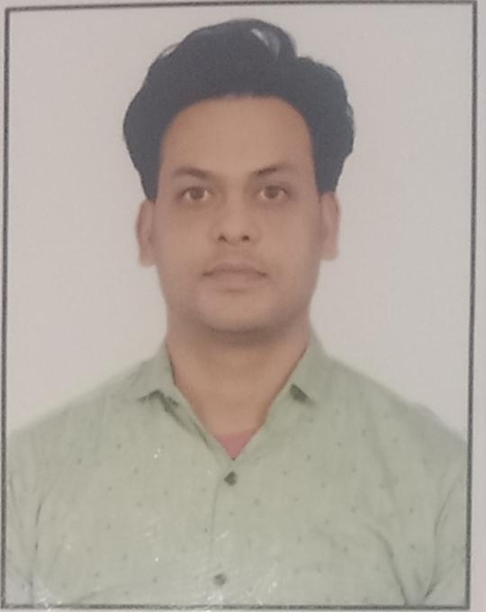

Gmail ID [ravirsinghh1@gmail.com](mailto:ravirsinghh1@gmail.com)

Email ID [ravirsinghh1@onmail.com](mailto:ravirsinghh1@gmail.com)

Add. : Ganesh Nagar, Jawad, Post- Dhoinda

Distt.- Rajsamand , 313324 (Raj.)

Mob No. : 9649913376, 7726879570

D.O.B. : 10/12/1992

Nationality : Indian

Gender : Male

**Carrier Objective:**

To work with an organization where I can prove my abilities. My aim is to contribute fullest on my part in the achievement goals. To work in a healthy, innovative and challenging environment extracting the best out of me.

**Skills :**

* Multi Tasking
* Disciplined
* Relationship Management
* Good Communication

**Academic Qualification :**

* M.Sc in Polymer Science & rubber tech. From University College of Science MLSU Udaipur in 2019 53.75%
* B.Sc in (Botany, Zoology, Chemistry) B.N.P.G. College Udaipur in 2014 with 53.00%
* Senior Secondary Class From RBSE Ajmer in 2010 with 58.31%
* Secondary Class From RBSE Ajmer in 2008 with 63.17%

**Academic Project- Industrial Training :**

* Organization : Somi Conveyor Belting Ltd. Jodhpur.
* Duration : 60 Days, From 01/04/2016 to 30/05/2016
* Project Title : Effect of filler doses variation on the properties of NR based compound. (Production Process & R&D Lab)

**Experience :**

EASY FLUX PVT. LTD. UDAIPUR

**Other Activities :**

* Participated in various Games in school and college level.
* I have completed RS-CIT course for computer education.

**Current CTC :** No

**Expected CTC :** 15000 to 20000 per month

**Personal Information :**

Name : Ravi Singh

Father’s Name : Mr. Ram Nath Singh

Mother’s Name : Mrs. Ramawati

Marital Status : Single

Nationality : Indian

Language : English, Hindi & Regional

Hobby & Interest : Social Work, Playing Cricket, Listening music, Reading books, Internet suffering.

**Declaration :**

I have certify that above details are true and correct.

**Date : 17/07/2022**

**RAVI SINGH**