Curriculum Vitae 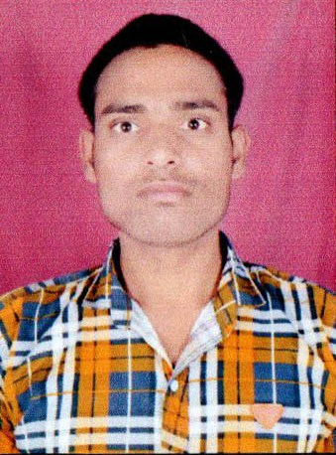

NITISH CHATURVEDI
VILL BHAU BUJURG POST GODHANI DISTT KANNAUJ
Pin- 209727 UP
Mob. 7355149228
E-mail- chaturvedik6@gmail.com

Career Objective

“To work in time with the objectives of the organization and utilize my potential to the optimum for the benefit and growth of the organization”

Professional Qualification

Qualification : B.PHARMA
Institute : VEDICA COLLEGE OF PHARMACY
Year of passing : 2014
Percenyage secured : 67%
University : R G T U Bhopal (MP)

Educational Qualifications

Standard : Intermediate (10+2)
Board : U.P. BORD
Name of School / College : R N Inter College HARDOI
Year of Passing : 2010
Percentage Secured : 67%

Standard : High School
Board : U.P. BORD
Name of School / College : K L S V M I C M NAGAR KANNAUJ
Year of Passing : 2008
Percentage Secured : 50%
WORK EXPERIENCE

3 YEARS ARSHI HOSPITAL & SURGICAL CENTER KANNAUJ
Additional Skills

- Having complete knowledge of Basic Computer Knowledge.
Core Strengths

- Discipline & Obedient.
- Hardworking & Strong will.

Soft Skills

- Strong learner and innovative.
- Ability to lead and motivate colleagues.
- Ability to lead and work with a group excellently.

Areas of Interest
- Production
- Sales & Purchase

Personal Profile

NAME : NITISH CHATURVEDI
DATE OF BIRTH : 01th July, 1993
FATHER’S NAME : MAHESH CHANDRA CHATURVEDI
ADDRESS : Vill. BHAU BUJURG POST GODHANI
: KANNAUJ PIN-209727 UP
Languages known : English and Hindi
Nationality : Indian
Gender : Male
Marital status : Single

Declaration

“I hereby declare that the above-mentioned information is correct up to my knowledge and I bear the responsibility for the correctness of the above-mentioned particulars.”

Date –
Place -
(NITISH CHATURVEDI)

