|  |  |
| --- | --- |
| **Post Applied For:**  Sale | |
| **Current Emp.:**  Plastene India Limited | **Designation:**  Senior Manager |
| **Education: PG** Diploma in Business Administration | **Age:**  47 yrs. |
| **Relevant Inds. Exp.:**  Yogi Pharmacy Ltd, OK Play India Ltd, Apollo Tyres Ltd, Total Fina Elf India Ltd, Reliance Industries Ltd, Plastene India Ltd, Birla Tyres (Kesoram Industries Ltd) | |
| **Current Location:**  Ahmedabad | **Home Location:**  Ahmedabad |
| **Current CTC:**  12 lac P.A | **Expected CTC:** Negotiable or Can be Same |
| **Mother Tongue: -** Hindi | **Language Known: -** Gujrati, Hindi, English |

**Sudhanshu Mehrotra** 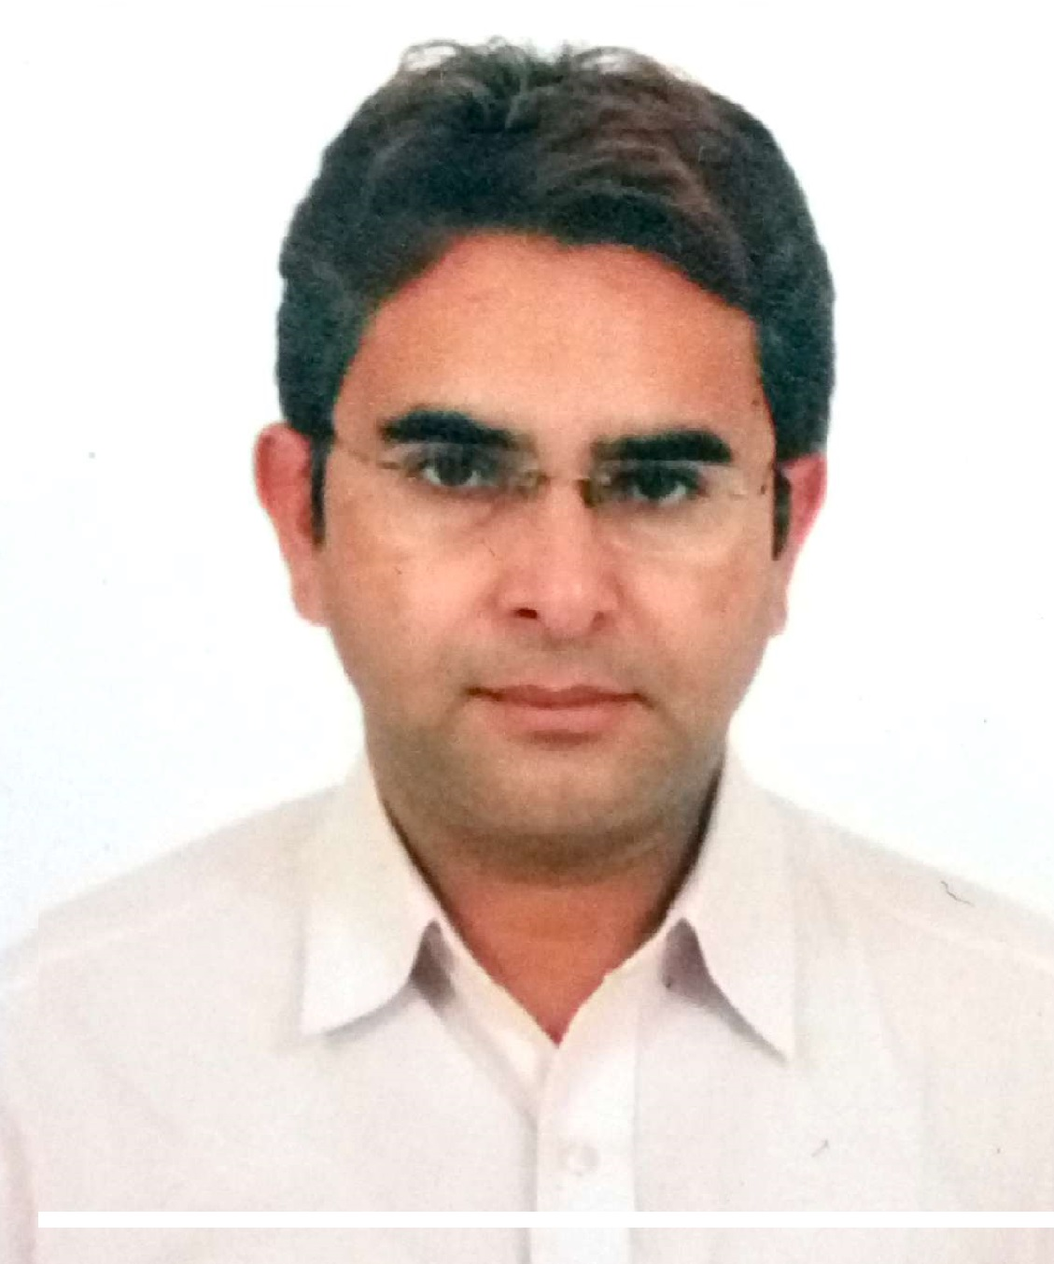

**Phone no.:** 09825223537; 09974092079; **Res. no.:** 9219444331

**Email:** sudhanshumehrotra@rediffmail.com; sudhanshumehrotra@gmail.com

**Looking for the middle/senior management position in Sales/Channel Management/Business Development**

* A seasoned professional with more than **20** **years** of experience in Strategic Planning, Business Development, Sales & Marketing, Channel Management, CRM and Man Management.
* Managing overall Sales & Marketing operations for the state of Gujarat.
* Expertise in managing business operations with key focus on top line profitability by ensuring optimal utilization of resources.
* Demonstrated abilities in cementing healthy relationship with the clients for generating business and leading workforce towards accomplishing business and corporate goals.
* Proven skills in managing teams to work in sync with the corporate set parameters & motivating them for achieving business and individual goals.
* Possess excellent interpersonal, communication and analytical skills with demonstrated abilities in customer relationship management.

**Key Result Areas**

**Strategic Planning**

* Overseeing the sales & marketing operations, thereby achieving increased sales growth.
* Utilizing client feedback & personal network to develop marketing intelligence for generating leads.

**Business Development**

* Establishing short/long term budgets in tune with corporate strategies for achieving business targets.
* Business planning, forecasting and analysis for assessment of revenue potential in business opportunities.
* Analyzing & reviewing the market response/ requirements and communicating the same to the sales teams for accomplishment of the business goals.
* Conducting competitor analysis by keeping abreast of market trends & achieving market share metrics.
* Implementing pre/post launch sales promotional activities for brand building & market development.

**Sales & Marketing**

* Conceptualizing & implementing strategies as a part of brand building and market development.
* Forecasting monthly/annual sales targets and executing them in a given time frame thereby retaining & enhancing existing & new clients.
* Devising & effectuating competitive selling programs/strategies to improve product awareness & enhance business growth.

**Distribution Management**

* Identifying and networking with financially strong and reliable dealers/channel partners, resulting in deeper market penetration.
* Ensuring cost effective logistic operations & seamless materials movement to ascertain sufficient inventory levels at each sales outlet/ distribution channel/company level.

**Client Relationship Management**

* Maintaining cordial relations with customers to sustain the profitability of the business.
* Maximizing customer satisfaction level by on time delivery, monitoring customer complaints, providing efficient services.
* Handling customer grievances and resolving issues.

**Man Management**

* Providing direction, motivation and training to the field sales team, ensuring optimum performance.
* Responsible for recruiting, mentoring & training executives to deliver quality services in market.
* Monitoring the performance of the staff members, providing training and motivation, & team leading at TCC & Retail outlets.

**Career Snapshot**

**Currently looking Marketing, Central Planning, Inventory management, for Plastene India Limited in Ahmedabad. Earlier headed Uruguay operations for Oliva Garden SA a Subsidiary of Plastene India Ltd engaged in manufacturing and Marketing of FIBC(Jumbo Bags and Woven Sacks) based at Montevideo(Uruguay) from Nov’16 to July’17.**

To Maintain and Increase Sales and Market of Company’s product. Establishing , Maintaining and Expanding the Customer base. Servicing the needs of existing Customers. Monitoring Team Performance and Motivating them.

Compiling and analyzing Sales Figures. Collecting Customer feedback and timely submission of the same to concerned department. Interdepartmental communication and Coordination to recommend appropriate Price Changes, to ensure Timely delivery. Keeping update of Customers and Competitors.

**Jun’10-Jul’16 Birla Tyres (Kesoram Industries Ltd)**

Sales Lead( Business Manager)

Handling the Tyre Sales of BIRLA Brand which include Truck, Car, Tractor, Light commercial Vehicles,2/3 wheelers tyres. Maximize sales of BT products through Channel partners i.e. Sales Agents, Dealers and Distributors. Responsible for development and expansion of Dealer Network of Non truck tyres in the Area. Sales Planning, forecasting and indenting of stocks at all depots. To plan and implement Sales Promotion activities at depot and to ascertain its effectiveness. Monitoring competitor activities in the trading area and devising strategies for sales. Responsible to monitor and reduce outstanding of dealers on a monthly basis. Report to HO on product performance, quality and achievement of targets. Tasked with resolving customer issues, complaints and grievances, if any. To regularly motivate team members of depot and help them achieve individual KRAs as well as KRA of the Area.

*Notable Contributions*

* Successfully launched 2/3 wheeler tyres range and establishing the same in the market.
* Consistently featured amongst top performer pan India
* Received appreciation letter from Chief Marketing Officer for consistent excellent performance.
* Received certificate of Star performer from President.
* Earned 2 Foreign Trip in inter employees competition.
* Establishing the network of 150+ dealers.
* Reached the level of 15000tyres in just the two and half year of Product launch.
* Triple the Sales in Rajkot Area.

**Mar`09-Jun’10 Plastene India Ltd.**

Marketing Manager

Role: Handle all levels of communication with affiliates, answer phone conversation and e-mails that will tackle in the area of answer different kinds of questions about the product, and terms of negotiations.

Manage daily marketing on the execution ad development of the project that would include creative developments and all implementation courses; ensure the compliance of strategies and standards of the product; oversee outside agencies and vendors.

To provide supervision which involves establishing and communicating division goals and results to employees, staffing the division and delegating the workload, actively supporting employee growth, and upholding company policies.

Enhancing of revenues through Domestic as well as International Business. Reviewing monthly accounts & reconciliation and projected budgets.

*Notable Contributions*

* Played a vital role in attaining base expansion from limited base to significant copious base.
* Carried out product exposure to the international market like UAE, Saudi Arabia, Africa
* Instrumental in handling commissioning of phase wise plant expansion from 40MT to 100MT per Month.
* Adeptly handled the capacity utilization to 100% consistently.
* Meritorious Performance for improving departmental performance from Mar09-Nov.09.

**Oct`04-Mar’09 Reliance Industries Ltd, (Petroleum Division Rajkot)**

Manager  Trans Connect Centre & Retail Outlets of Saurashtra Region

***(Joined as Fleet Sales Manager & promoted to Trans Connect Manager)***

Role: Administering daily Sales & Commercial activities at the Trans Connect Centre. Handling customer acquisition & sales through Fleet Management Program at TCC & Retail Outlets. Developing brand promotional programs for creating awareness about value added services offered by Reliance. Responsible for Sales of Non-Fuel Products like Lubricants, Tyres, Filters.

*Notable Contributions*

* Significantly contributed in accomplishment of no.1 position in terms of sales through fleet cards in the country.
* Achieved highest no. of customers activation in Fleet management Program in the country.
* Among top 10 in country in terms of Lubricants & Tyres sales.
* Successfully organized mass customer meets & to float schemes, increase awareness about the product quality and other value added services offered by Reliance.
* Developed & implemented various measures viz. monitored daily performance, formulation of one to one relations with customers for maximization of collection at Trans Connect Centre.
* Identified training requirements of the staff members & organized training programs viz. **Practical Operational** & **Refresher Training** for enhancing performances.
* Coordinated & communicated with key clients.
* Achieved 1000 KL club of HSD sales through Transconnect Cards, across India.
* Significantly contributed in average collection of **1.5 crores** (monthly) at Transconnect centre.

**Dec`02  Sep`04 Total Fina Elf India Ltd, Ahmedabad**

**Senior Area Executive**

Role: Directing sales operations for Ahmedabad, Bhavnagar, Surendranagar and Kutch districts. Handling all activities pertaining to Distributor & Dealer Management, Sales & Collection.

*Notable Contributions*

* Conducted training programs for distributors staff.
* Significantly contributed in:
* Enhancement of sales by 200% at Ahmedabad
* Revival of the distributor at Porbandar
* Among top 10 **in** country for 4 stroke 2wheeler oil sales.

**Mar`98  Nov`02 Apollo Tyres Ltd**

**Marketing Executive, Rajkot**

***(Joined as Sr. Sales Executive & promoted to Marketing Executive)***

***Role****: Supervising sales/marketing/sevice operations for Rajkot, Jamnagar and Porbandar districts. Managing activities related with Dealer management, Sales planning & monitoring the outstanding, Inventory management, increasing the dealer network in urban as well as rural markets and conducting mass customer meets.*

*Notable Contributions*

* Successfully administered turnover of Rs. 2 crores per month with Apollo Tyres with total contribution of 65% in sales of Rajkot Depot.
* Efficiently identified & developed 12 potentials dealers in Rajkot, Jamnagar, Porbandar territory in Apollo Tyres.
* Essayed a stellar role in establishment of Kaizen and Amazer brand in the market.

**Previous Experience**

**Aug`96  Feb`98 OK Play India Ltd., Delhi Sales Executive**

**Dec`94 - Jul`96 Yogi Pharmacy Ltd., Delhi Executive Marketing**

**Scholastics**

1994 **PG Diploma in Business Administration** with specialization in Marketing from

Institute of Productivity & Management, Ghaziabad.

1991 B. Com from M. M. (PG) College, Modinagar, Meerut University.

**Personal Profile**

Date of Birth: 6th December, 1971

Fathers Name: Sh. R.P. Mehrotra

Marital Status: Married

Present Address: Tulip 5, Shukan 6 Apartment ,Opp Science City

Sola, Ahmedabad-380060(GUJ) India

Permanent Address: S.B.13 New Modi Market, Modinagar-201204, District - Ghaziabad, UP, India

Languages Known: English, Hindi & Gujarati