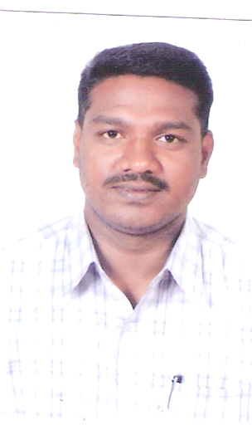

1. **SADIQUE BASHA.**

**(Over 20 years of experience in Accounting & Inventory Management)**

Post Box No. 5115

Dammam

Kingdom of Saudi Arabia

Mobile # 00966 553932137

No.3, Ghandiji Street

Beedi Colony,

Behind Modern 3Star Rice Mill

Ariyamangalam

Trichy 620 010

Tamil Nadu - India

Mobile # 0091 9600521948

# **Email: nawfalsadique@gmail.com**

**Career Objective**

My goal in career is to achieve professional excellence and contribute my whole hearted efforts for the benefit of an organization that provides me a platform to utilize my knowledge and experience while learning the latest advancements in the accounting domain.

**Professional Strengths**

* Experience of using advanced accounting applications for different industries
* Ability to indulge myself in learning so as to stay updated with the most recent happenings in the industry
* Ability to initiate communication with internal and external public and maintain effective professional relationships in the long run
* Skilled in handling problematic situations and tactfully dealing when conflicts occur among the employees in the department
* Passionate to leave a trail of excellence through hard work and leadership

**Details of Work Experience**

**SENIOR ACCCOUNTS EXECUTIVE- ABDULLAH H. AL SHUWAYER SONS T&C. CO. DAMMAM, K.S.A**  
Working since Sept. 2008

**Job responsibilities**

* Prepared the Financial Statements and Balance sheet variance analysis and performed monthly review with the CFO
* Lead the monthly Accounting close process for the Shared Service Center.
* Recorded All monthly accounting entries in accordance with IFRS
* Investigated the material or unusual variance/fluctuations on the consolidated and legal entities balance sheet, income statement and cash flow statements.
* Co-ordinate with subsidiaries and HQ accounting team to ensure intercompany activity is properly recorded and eliminated upon consolidation and lead the intercompany financial audit.
* Liaised with independent auditors in completing annual financial statement audit.
* Ensured the effective design and operation of internal controls over financial reporting with in the corporate accounting function.

**CHIEF ACCOUNTANT AT HAMED A. H. AL GHAMDI CO., JEDDAH K.S.A.**  
Worked from October 2001 to June 2006

**Job Responsibilities**

* Developed and implemented schedules pertaining to the preparation of account books
* Recruited, trained, evaluated, promoted, and fired employees in the department
* Conducted internal checks prior to audit to resolve any discrepancies
* Responsible for accounting activity related to invoicing collection, and sales receipts; report and report to Executive Vice President – Finance.
* Responsible for Receiving all Customer Confirmation on monthly Basis.
* Accountable for planning stocks according orders received, verifying physical stock against computer stock and yearend stock verification and valuation.
* Maintained over 7 bank transactions and monthly reconciliation, and handled Main cash and introduced system of depositing complete cash in daily basis and replenishment petty cash to Branch office.
* Involved in payment follow up and reconciliation of outstanding statements
* Co ordinate with Sales Team for confirmed orders, processing sales invoice.
* Generating yearend account statements and exposure of Depreciation, Audit Assisting, yearend account finalization.

#### **JTC Steels Co., Trichy**

**(Having Over 5 branches in Tamil Nadu)**

Job Title**: Accountant** July 1994 – Aug. 2001.

* In charge of maintaining daily routine expenses and system updating; report to Finance Co coordinator.
* Responsible for banking functions – Negotiation for temporary OD facilities and post dated instruments, and responsible for fixed deposits.
* Handled accounting package installation & submitting working reports to management.
* Accountable for maintenance of account books and preparation of report pertaining to stock, cash and monthly reports manually, Involved in finalization of account

### **ACADAMIC REVIEW**

* Bachelor of Commerce, Jamal Mohamed College, Barathidhasan University, Trichy, Tamil Nadu, India. (1991-1994)
* Diploma in Computer Applications, Jamal Mohamed College, Trichy, Tamil Nadu, India.
* Studying “**ACCA”**(Association of Chartered Certified Accountant)

### **IT EXPOSURE**

*Operating System : Win 98/2007/xp.

*Application: Ms office 2010, Word Perfect and Word Excel.

*Accounting Package: GRAMSYS TALLY & ERP

### **PERSONAL PROFILE**

Date of Birth: 4th May 1972

Gender: Male

National: Indian

Religious: Islam

Status: Married

Known Languages: English, Arabic, Hindi, Urdu, Malayalam& Tamil