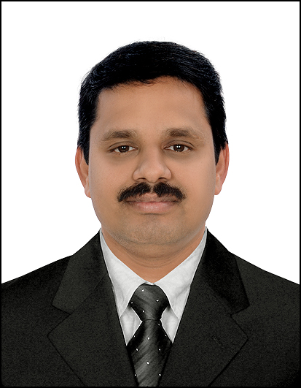

RAJESH.M
Thrissur, Kerala
Mob: 0091 9207327353
rajeshkartha@gmail.com; rajesh_kartha@rediffmail.com

Email-id: rajesh_kartha@rediffmail.com, rajeshkartha@gmail.com

hotmail.com

Personal Information

- Nationality : Indian
- Place & Date of Birth: Kerala, 17/01/1976
- Languages Known: English, Hindi & Malayalam

Objectives

Seeking Challenging assignments, where my capabilities can be exploited for the growth of the company and provides ample scope of career growth.

CORE PROFESSIONAL STRENGTH

As a Successful professional with 23 years of experience in Sales & Service Coordination and Supervision, I possess:
- Excellent and strong communicational, organizational and analytical skills.
- Ability to create and deliver dynamic presentations.
- Background of working in multicultural environment.
- Passionate, hard working and well-organized professional with power to prioritize and multitask. Pays attention to detail.
- Ability to meet deadlines. Able to work in team and willing to put up to team.

CAREER HISTORY

Al Saeedi Middle East Fzco- Jafza, U.A.E (Nov, 2019 to Present)
Sales & Service Coordinator

- Managing all the Sales & Service related activity of the Service Center.
- Effectively communicating with customers in a professional and friendly manner.
- Contacting potential customers to arrange appointments.
- Resolving any sales related issues with customers.
- Process to enquire, receive calls by phone, Whatsapp and email.
- Responsible for accurate and timely issue of Quotations/ Proforma Invoices to the customers as required.
- Provide after sales support when required.
- Undertake job cards, and assist workshop foreman to carry out the service check list.
- Up-sell and cross-sell company products and services offered by the outlet to maximize the turnover and profits from each job card.
- Responsible & Accountable for divisional Stock.
- Receive materials and verify it against Delivery Note and keep on tacking for material replenishment below re-order level.
- Physical stock verification at regular intervals.
- Follow first in first out system for materials and last in first out for products with a shelf life.
- Follow up on customer payments on regular basis.

Emirates Transport - U.A.E (May, 2016 to May, 2019) Store In Charge.

- To exercise general control over all activities in Stores Department.
- To ensure safe keeping both as to quality and quantity of materials.
- To reserve a particular material for a specific job when so required.
- To issue materials only in required quantities against authorized requisition notes/material lists at the right time.
- To check the book balances, with the actual physical stock at frequent intervals by way of internal control over wrong issues, pilferage, etc.
- Store the materials in the allotted places with coding for easy identification of every item of stores.
- Maintain proper record of receipt, issue and balance of all items of materials.
- Maintain the Stores department in a tidy manner.
- Protect material from losses due to fire, theft, evaporation, obsolescence etc.,
- Ensure that the stock neither exceed the maximum level nor go below the minimum level at any point of time.
- Prevent unauthorized persons entering into the stores.
- Co-ordinate the work of staffs in the stores department.
- Advise management of obsolete and slow moving stocks.
- Collecting the quotation, arranging materials, making purchase requisition/P. O/GRN, Supervision etc.

Al Dobowi Tyre Company L.L.C- U.A.E (Nov, 2010 to Nov,2015) Sales Supervisor.

- Ensure compliance of corporate policies and procedures.
- Effectively communicating with customers in a professional and friendly manner.
- Converse with customers to identify their purchasing requirement and assist in locating desired items.
- Provide customers with essential product information, as well as offer them a demonstration of product features.
- Direct or escort customers to appropriate aisles or stores sections where they can find choice products.
- Provide solutions or replies to address customers’ problems or inquires.
- Provide customers with after sales services and warranty agreements.
- Monitor displayed products to facilitate replenishment of emptying shelves.
- Oversee the upkeep,maintenance and general cleanliness of a store and it’s premises.
- Collect cash payments and process credit card transactions for the purchase of goods.
- Handle cases of product return, refund or exchange.
- Maintain an up-to-date knowledge of store products and services in order to effectively conduct sales.
- Upsell and cross sell in order to Increase sales and maximize company profits.
- Work closely with retail sales managers to ensure sales targets are achieved.

MRF Tyres Ltd-India(July, 2003 to Sep, 2010) Sales Depot In-Charge

- Interacting with customers to enhance good sales.
- Processing invoice, timely & accurately, against the customer/dealers order.
- Responsible for dispatches of invoiced materials to the customer/dealers on time.
- Physical Verification of stock.
- Reconciling dealers accounts and follow up to recover the outstanding amount.
- Keeping tab on the funds and maintaining enough balance in bank account.
- Verification of vendor bills with contract, processing for payments & proper accounting the same.
- Handling petty cash and accounting of day to day expenses.
- Scrutinizing monthly expenses with budget and taking effective steps to reduce the avoidable expenses.
- Reconciliation of bank statements on a monthly basis.
- Keeping control on issuing credit notes to the Dealers.
- Issuing quotation to Govt. Departments and materials supply.
- Keeping Staffs records and books and registers as per Labour Department’s guidelines.
- Making work schedules of Technicians/Helpers and coordinating with them to get the works done in time.
- Preparation of schedules on quarterly basis for audit purpose.
- Preparation and submission of Sales & Income Tax returns to the tax authorities on time.
- Responsible for deduction of Service Tax/Professional Tax/ T.D.S under various sections from the payment and remittance to government on time.

VENUS WIRE Industries Ltd -India (Feb, 1997 - June, 2003) Accounts Executive.

- General Accounting and Finalization of Accounts.
- Handling petty cash and day-to-day expenses
- Monthly preparation of bank & stock reconciliation statements.
- Preparation of Vouchers, Cheques, Salary payments, Travelling Expenses payment and submission of monthly stock statement in bank to get Over Draft Facility
IT SKILLS

- Operating Systems: Windows 10
- Work Experience in SAP, Orion, Oracle E-Business Suite, Tally, MS Office
EDUCATION & PROFESSIONAL DEVELOPMENT

- MBA (Export/Import) from National Institute of Business Management, Chennai.
- Bachelor of Commerce from Calicut University, Kerala in the year 1996.
- Diploma in Computer Applications from IRS Computer& Communications in the Year 1997.
- Typewriting (Lower& Higher) passed from Board of Technical Examinations Kerala State in the Year 1994.

I hereby affirm that the above-mentioned information furnished by me is legitimately correct and no relevant fact is suppressed.

_________________
RAJESH.M

