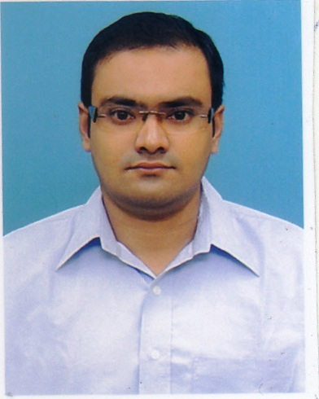

37/1 Brindaban Mullick Lane, P.O- Kadamtala,

Howrah-1 P.S-Bantra,

Dist - Howrah

Pin no.711101

ANIRBAN CHAKRABARTI State – West Bengal

PERSONAL PROFILE:

      - DATE OF BIRTH : 19th October, 1983

      - FATHER’S NAME : Rabindranath Chakrabarti

      - CONTACT NO. : (0) 8240654655

- E-MAIL : anirban.ch83@gmail.com / anirban.c83@rediffmail.com

- PASSPORT NO : N1126282

      - NATIONALITY : Indian

      - RELIGION : Hindu

      - MARITAL STATUS : Married

      - SEX : Male

      - LANGUAGE KNOWN : English,Bengali,Hindi

      - OBJECTIVE:
To build my career in a progressive organization in a leading position, that will provide me exciting opportunities to utilize my Accounting & Financial skills and experience in such a way to add more value to the organization and to learn more about Accounts & Finance.

- ACADEMIC PROFILE :

Exam passed | Board / University | Year of passing | % of Marks
MBA(Finance) | SIKKIM MANIPAL UNIVERSITY | 2012 | 80.38
M.Com | BURDWAN UNIVERSITY | 2008 | 43.83
B.Com(Hon’s) | CALCUTTA UNIVERSITY | 2005 | 52.75
Higher Secondary | W.B.C.H.S.E | 2002 | 65.00
Madhyamik | W.B.B.S.E | 2000 | 59.25

EXTRA QUALIFICATION : Basic Course of Computer (Indian School of
Advance Studies)
Ms-dos, Windows, Ms Office (Word, Excel, Power
Point), Internet.

: Financial Accounting (Ramakrishna Mission
Computer Centre)
Dos, Windows, Tally (7.2 & 9), EX-Next
Generation, Accord, Fact

PROFESSIONAL EXPERIENCE:

(A)

ORGANIZATION : SMARTWORKS COWORKING SPACES PVT LTD)

DESIGNATION : JUNIOR ACCOUNTANT

TENURE : Worked from 22nd August’22 to till date

JOB PROFILE :

Purchase Entry of Jaipur, Noida and Delhi Branch in tally prime.
- Vendor Reconciliation.
- Prepare Bank Reconciliation Statement.
- Branch visit for Internal Audit.
- Some of my responsibilities handling CAPX & OPEX for accounting purposes.
- Knowledge to work in Dynamics 365.

(B)

ORGANIZATION : P.S. EARTHMOVERS PVT LTD (TATA HITACHI)

DESIGNATION : ACCOUNTANT

TENURE : Worked from 2nd May’19 to 30th July’22

JOB PROFILE :

Maintain petty cash.
- Cash related transaction in SAP.
- Prepare Cash Book register in Excel.
- Daily basis Branches Cash Book verification.
- Prepare E-Way Bill & J-SON Way Bill in daily basis.
- Maintain Travelling Allowance Tracker & reconcile ledgers.
- E- Invoice generate & failure checking through JSONLint.
- Transporter bills verification & Process.
- Vendor Reconciliation.
- Prepare Bank Reconciliation Statement.
- Branch visit for Internal Audit.( Physical Cash & Stock verification )

(C)

ORGANIZATION : HITECH CELLPHONE PVT LTD

DESIGNATION : ACCOUNTANT

TENURE : Worked from 1st February, 2014 to 14th April’2019

JOB PROFILE :

Prepare Credit Note & Debit Note through Tally ERP.
- Generate E – Way Bill (both domestic & International)
- Maintaining & updating company’s various Bank books through internet banking.
- Preparation of Bank Reconciliation Statement.
- Maintaining & Recording all petty cash, indirect expenses in Excel & Tally.
- Prepare Purchases & Sales entry in Tally.
- Preparation of Outstanding List of Sundry Debtors.
- Age wise bill adjustment of Sundry Debtors.
- Manufacturing / Production Accounts (including BOM) done through SAP / TALLY.
- Prepare Report of DSA, Finished Statement & Utilization Sheet.
- Prepare Production wise Bond report in Excel.

(D)

ORGANIZATION : BHANDARI AUTOMOBILES PVT LTD. (Tata Motors)

DESIGNATION : ACCOUNTANT

TENURE : Worked from 1st November, 2012 to 31st October, 2013

JOB PROFILE :

- Responsible to handle the computerize Accounting in Tally ERP 9.
- Verification vendor's bill & preparation cheque
- Handling and Maintain Total petty cash.
- Preparation of Bank Reconciliation Statement.
- Voucher Preparation & purchase entry.
- Preparing money receipt in SIEBEL (Oracle software).
- Prepare Oil Statement in Excel sheet.

(E)

ORGANIZATION : SRMB SRIJAN LIMITED

DESIGNATION : LOGISTICS EXECUTIVE

TENURE : Worked from 1st February, 2010 to 31st May, 2010

JOB PROFILE :

- Processing bills on the basis of receipted challan coming from various parties.
- Maintain Despatch Register and preparation of Daily despatch in Excel.
- Responsible for maintaining a record of all outstanding purchase orders with external vendors.
- Preparation of Sale Order for prompt execution of customer order.

- PROJECTS : Projects on

- Working Capital done under the guidance of Sikkim Manipal University, in 2012.
- Tally 7.2 done under the guidance of Ramakrishna Mission Computer Centre, in 2006.

  - FIELD OF INTEREST : Computer Operation and Accounting

- HOBBIES : Travelling ,Reading Books & Magazines, Photography,
Hearing Songs.

- REFERENCES : Available on request

PLACE: HOWRAH
--------------------------------
DATE : Anirban Chakrabarti
(Signature)

