Anil Khajuria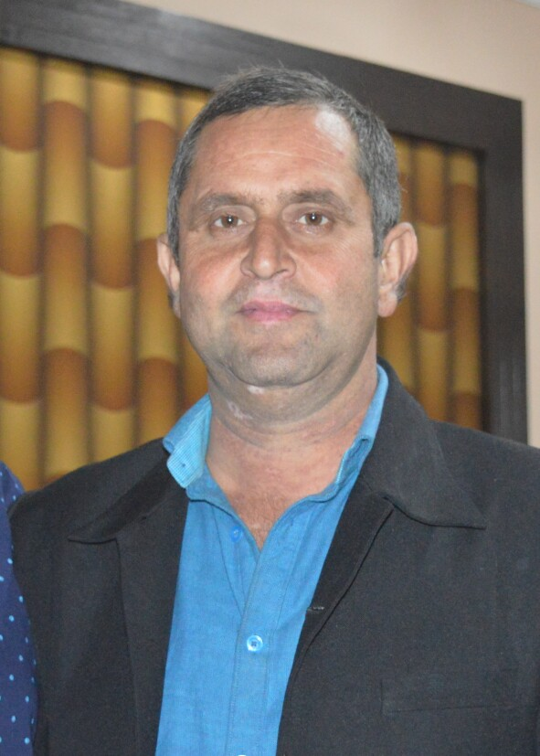
WARD NO 5 H NO 49
MOHALLA BARRIAN
UDHAMPUR (J&K)
Pin: 182101
Mob,,9622121742 ,LANDLINE 01992-271470(R)
E-mail: anil_khajuria2003@yahoo.co.in
anil_khajuria2003@hotmail.com
KHAJUANIL2021@GMAIL.COM
Objective | I am a retail marketing consultant seeking a full-time position in the field of retail and marketing, where I can apply my knowledge and skills for continuous improvement. I have broad experience in retail management and market research, developing strategies that drive products to success
Experience | BRAZA TYRES PVT LTD (MAY 2019 ONWARDS AS SR TERRITORRY MANANGER IN BRAZA TYRESS PVT LTD  INCHARGE J&K .  Job Profiles:  LOOKING AFTER SALES OF BRAZA TYRES IN J&K  LOOKING AFTER WARRENTY OF CLAIMS  FITTER MEETS & TAXI STANDS AND MATADOR FLEET  DEC 2011 ONWARDS TILL DEC 2013  CEAT LTD AS PROJECT MANANGER CEAT SHOPPIES YAMUNANAGAR HARYANA (  Job Profiles  LOOKING SALES OF DEALERS AND FLEETS  LOOKING AFTER WARRANTY OF CLAIMS OF TYRE  CUSTOMER CONVERSIONS  FLEET ACCOUNT ADOPTION AND DEVELOPMENT  LOOKING AFTER YAMUNANAGAR CFA ,JALANDHAR  ACHIEVEMENTS WON TWO TIME INCENTIVE IN 2 QUARTERS IN JULY-DEC13  MAX TARGET ACHIEVER IN MOTOR CYCLE/SCOOTER/ IN FARIDABAD REGION IN IN MAR12-MAR13  TRAINING ATTENDED  DONE ONE MONTH TRAINING IN DELHI IN FIELD AND INSPECTION OF CLAIMS IN HALOL RADIAL PLANT AND IN MUMBAI HEAD OFFICE  (AUG10-DEC11  VALVOLINE CUMMINS LTD AS A TERRITORY BUISENESS MANANGER (AUG10-DEC11) TERRITORRY BUSINESS MANANGER  MANANGER(J&K)  Job Profiles: -  LOOKING AFTER SALE OF VALVOLINE PRODUCTD IN J&K  ORGANISING ROAD SHOWS AND NUKKAR MEETS  ORGANISING CUSTOMERS SERVICE CAMPS ALONG WITH RETAILERS  LOOKING AFTER CUSTOMERS COMPLAINS IF & GRIVENCES IF ANY AND SATISFY THEM  LOOKING AFTER THREE DISTRIBUTORS IN J&K  (MAY 06-AUG10 ) J K TYRE & INDUSTRIES LTD AS TERRITORY INCHARGE JAMMU  JOB PROFILE  CREATING PRODUCT AWARENESS& BRAND AVAILABILITY  TRAINING THE END USER ABOUT THE TECHINICAL APPLICATION PROCESS  ORGANISING SEMINAR &ROAD SHOW, MELA MEETS  INTERECTING WITH END USERS/SUPPLIERS  RETAIL CHAIN MANANGEME.  - ATTENDING OE COMPLAINS OF MARUTI AND OTHER OEMS  LOOKING AFTER THE WARRANTY CLAIMS  ACHIEVEMENTS MAXIMUM TARGET ACHIEVER OF CAR RADIAL SALE IN PUNJAB & J&K  ACHIEVED BANGKOK TRIP IN 2008  ACHIEVED HIGHEST TRUCK TYRE SALE IN 2008-2009  TRAINING ATTENDED  SEVEN DAYS TRAINING IN WARRANTY AND CLAIM INSPECTION IN GWALIOR PLANT & TWO PROGRAME IN SALES PROCESS AND ONE PROGRAME IN TIME MANANGEMENT  (MAR 03 –MAY 06 ) CEAT LTD.AS A SERVICE ENGG  TERRITORY MANANGER (CUSTOMER SERVICE DEPARTMENT )  Job Profiles: -  * INDEPENDENT HANDLING OF PUNJAB,JAMMU DEALERS & FLEETS  - HANDLING OF WARRANTY CLAIMS OF TYRES OF ALL RANGE TRUCK AS WELL AS PCR,M/C AND S/C ,UVR AND TUBES  - CUSTOMER CONVERSIONS USING OTHER BRANDS  - FLEET ACCOUNT ADOPTION AND DEVELOPMENT  - ATTENDING OE COMPLAINS AND CLOSURE OF CTC  - COVERED BATHINDA,JALANDHAR,AMRITSAR AND JAMMU CFA AND ON DEPUTATION GANGANAGAR CFA,S  ACHIEVEMENTS  - Customers Conversions. 6 to 7 Per Month.  - Reduced wrong adjustments from 12% to 2.5%  - Handling south Punjab’s dealers effectively  - Lowest wrong adjustments  - Max target achiever in fleets sales  - Lowest wrong adjustments in 2003-2004-2005  TRAINING ATTENDED  DONE 2 MONTHS TRAINING FOR INSPECTION OF TYRES IN BHANDUP AND NASIK PLANT
e | OCT2000–MARCH 2003 J&K VEHICLEDES PVT LTD UDHAMPUR (J&K)  SALES AND SERVICE OFFICER (CSD)  - RECEIVED THREE DAYS TRAINING ON B SEGMENT CARS  - LOOKING AFTER SALES OF MARUTI PRODUCTS TO ARMY PERSONALS THROUGH CSD  - ORGANISING ROAD SHOWS AND DEMOS
Education | 1999 -2000 BE MECH FROM DR BABASAHEB AMBEDKAR UNIVERSITY AURANGABAD  - B.E.,( MECHANICAL ENGG). (First division)  - Bsc. Non medical J&K university  - Graduated with first division.
Interests | Traveling, running, music.
Personal Details | - DOB: 20/04/1972  - Height: 5’10”  - Chest: 34”  - Waist: 32”  - Blood group: O+  - Marital Status: Married  - Parentage: Sh. J. L. Khajuria  - Profession: Engineer
Community Activities | - Diploma in Civil Defence  - Diploma in Marshal Art
Languages Known | - English  - Hindi  - Punjabi  - Dogr

REFRANCES RAVI AGGARWAL BLUE STAR LTD MOB 09810144394
UDIT TYAGI BUSHAN STEELS LTD
MOB 07011579041

