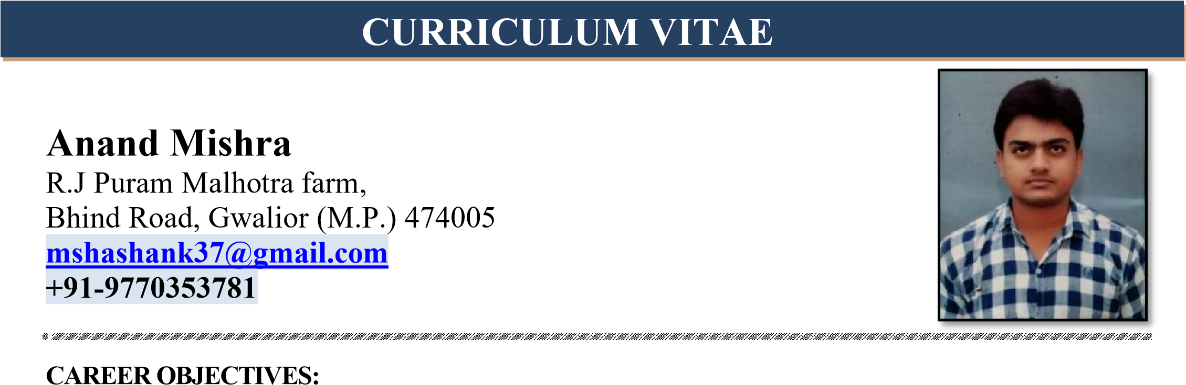

Seeking a opportunity to serve in your esteemed organization and prove myself worthy in the uplift of the organization.

**EMPLOYMENT RECITAL**

From- Nov-2019 - current

Organisation – Speedways rubber company

Designation- Maintenance & project Engineer (Mixing Maintenance)

From - June-2019 to Nov-2019

Organisation- Hindustan Abhikaran

Designation- Area Sales officer ,

From – May- 2018 to April 2019

Organization- JK Tyres& Industries Ltd. Banamore, Gwalior-M.P.

Designation – Graduate Apprentice Trainee (Tire Building & Stock Preparation)

**COMPANY PROFILE:**

Speedways tyres is a part of well known speedways group of companies in india leading manufacturer of farm radial, agriculture Industrial &OTR tyres, tubes and flaps and also of precured and conventional Tread Rubber.

**AREA OF EXPERTISE (TYRE INDUSTRY) :**

* **TBM Section:**Tire Building Machines (Unistage- Matador, BJ Two stage- China, SAI Machine- Italy, IRM – Holland, VMI- Holland, GTIC & NRM )
* **Cutter Section**:Konstructa Cutter (Czechoslovakia).
* **Stock Preparation Section :** Cap strip Slitter, Camroon Slitter, ProtplySlitter
* knowledge of A division (Extruder,4- roll calendar, 3- roll calendar, Triplex, etc)

**PROJECT EXPERIENCE:**

* Erection, installation & Establishment of 86 mtr long hot extruder line (Triplex).

**RESPONSIBILITIES:**

* Controlling the overall shift activity , preventive maintenance activity , other daily routing activity , assessing and analysis the daily break down and troubleshooting through why-why analysis.
* Action plan to reduce break down trend by kaizen activities.
* Taken countermeasure for the reoccur problems or modification as per the production, quality or safety requirement.
* Involve in Planning and execution for shut down jobs.
* Managing the safety in the plant and minimizing accidents/ losses.
* Involved in annual, monthly preventive maintenance schedule.
* Responsible for manpower handling, planning for un-interrupted & smooth services. Ensure the generation of utilities with safe operation.
* Monitor the spares requirement & make sure that necessary spares are available with a control on the stock inventory to minimum.
* Responsible for carrying out preventive maintenance activities.
* Sound knowledge of pneumatic system, Gear mechanism & chain drive stystem.

**ACEDEMIC DETAILS:**

* Bachelor Of Engineer in Mechanical from R.G.P.V. University, Bhopal with 7.12 CGPA

**TRAININGS & WORKSHOPS:**

* Attended a Fifteen Days Short Term Training Programme on **“CAD SOFTWARE”** in 2015.
* Attended a Six Days Short Term Training Programme on **“ANSYS Mechanical”** in 2016.
* Attended a Fifteen Days Short Term Training Programme on **“SOLIDEDGE”** in 2015.

`

**INDUSTRIAL TRAINING:**

**Industry:** JK TYRE & INDUSTRIES LTD, Banamore, Morena M.P.

**Duration:** 15 Days

**Description**: Visited Organization for taking technical knowledge on manufacturing of tyre.

**COMPUTER PROFICIENCY:**

* **Knowledge of Designing software’s:-** AutoCAD Basic
* **Packages:- MS** Office, Power Point, MS-Excel,
* **SAP Transition Module**:-Maintenance.

**STRENGTH:**

* Hard working and dedicated in order to reach goal in time.
* Sincere and well disciplined.
* Positive attitude and helpful nature.
* Loyal and determined.
* Adaptable to kinds of environment.
* Good in time management.
* Work effectively with diverse groups of people.

|  |  |
| --- | --- |
| **PERSONAL DETAILS:** |  |
| **NAME** | **:** Anand Mishra |
| **GENDER** | : Male |
| **FATHER'S NAME** | **:** Mr. Sunil Kumar Mishra |
| **MOTHER'S NAME** | **:** Mrs. Geeta Mishra |
| **DATE OF BIRTH** | **:** 26 August 1995 |
| **MARITAL STATUS** | **:** Married |
| **LANGUAGES KNOWN** | **:** English and Hindi |
| **DECLARATION:** |  |

I, hereby declare that the information given above furnished by me is true to the best of my knowledge and belief.

**Date:**______________

**Place:______________** **Anand Mishra**