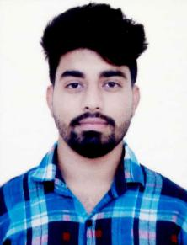

**GURJIT SINGH**

: +91-8146401266

: gurjitbasra9@gmail.com

Address: VPO Kangrour, Teh. Banga, Dist. SBS Nagar (Punjab)



**ENGINEER (CHEMICAL ENGINEERING )**

**Targeting enriching and leadership assignments in Quality Management & Control with a leading organization**

***Acknowledged for strengthening companies to lead in highly competitive markets by facilitating swift corrective actions, significant cost savings and fault-free audits.***

**PROFILE SUMMARY**

* **B.E. (Chemical engineering)** with **8 months** of experience from **24th Oct 2018** to **10th June 2019** in **Zinc, Zinc Electroplating** at **PRECISION INDUSTRIAL FASTENERS Ludhiana.**

~ Process handling, Quality Management ~ Quality Control ~ Quality Audits & Inspections of final product ~ Documentation ~ Production Management~Compliance ~ Resource Management.

* Right now I am working in **Ralson India Ltd.** as a Tech. Engg. from **11th June 2019.**

~ Able to **Bicycle Tyre Manufacturing** process control e.g.: to solve the whole problems from Extrusion to Final Curing process.

~ Rejection Control, Process audit and Documentation.

~ Perform general housekeeping and engineering-related inventory

duties.

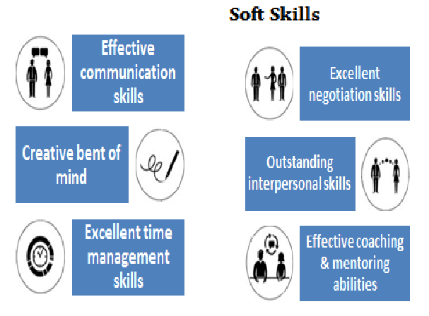

* Expertise in **applying total quality management tools and** **approaches** to analytical and reporting processes within the businessunit; skilled in formulating and maintaining quality control objectives complementary to corporate policies.
* Excellence in **investigating, analyzing& correcting problems in** **quality**; **assuring that all materials represent maximum quality** byestablishing effective quality control inspections
* Proficiency in **ensuring strict adherence to various, ISO and**

**Indian Standards.**

* An effective communicator with strong leadership, people management, analytical & problem-solving skills

**ORGANISATIONAL EXPERIENCE**

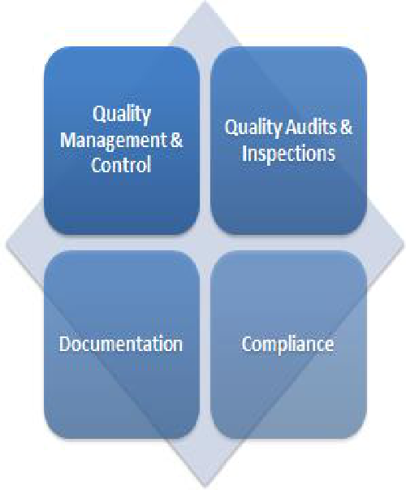**From Oct-24 -2018 to Jun-10-2019: PRECISION INDUSTRIAL FASTENERS, Sua Road, LUDHIANA (INDIA)**

Oct’24 2018 to Jun’10 2019:

Graduate Trainee

Engineer



Jun’11 2019 – Till date **RALSON INDIA LIMITED**

Assist. Tech. Engineer

**Key Result Areas:**

**Precision Industrial Fasteners:-**

* **Production management :** monitor the manpower handling, production planning and in-process material manipulation as per urgent plan, in-process tag and material movement, in-process breakdowns
* **Resource management :** material issue from store, official order for goods
* **Bath Analysis:** Conducting analysis of Acid baths, Zinc Baths,Anodic and Soak Baths related to its analysis, pH, Density & Temperature
* **Annealing Records:** Maintaining raw material inspection, annealing & finalinspection records of Bearing Grade Material
* **In-process Testing Record:** Maintaining in-process testing record related to impurity,ppm of impurity and TDS in operating baths, hydrogent embrittlement test
* **I.S.I. Records:** Keeping I.S.I. records for final inspection of different sizes and raw material testing record with referenceto its heat no. monthly production
* **Incoming Inspection of Raw material:** Conducting inspection of all incoming materials related to platingandinspection of acid
* Supervising implementation of the quality system of ISO 9001:2008 in the company
* Maintaining final inspection records of water consumption in electroplating department.
* **Rejection & Rework Records:** Maintenance of monthly rejection record
* **Customer Complaint Records:** Maintenance of customer complaint record &developing corrective & preventive action
* Validation of annealing pickling
* **Quality plans & Sampling:** Developing quality & sampling plan and issue new amendment
* **Analyzing& releasing raw materials and finished products, bought-outs** as per the pre-set qualityparameters; conducting rejection analysis and conducting vendor quality audit for improvement of product quality at their site
* **Monitoring preparation of quality documents by working in close coordination with Engineering/Development department;** analyzing customers & design requirements and establishing customer and other documents.

|  |  |
| --- | --- |
|  | **TRAININGS** |
| **Organizations & Synopsis:** | * An Industrial Training at National Fertilizers Limited, Bathinda, (Punjab) * An Industrial Training at The Nawanshahr Sugar Mill Industry, SBS Nagar, (Punjab) |
| **Duration** | 6 weeks each |

**PROJECT UNDERTAKEN**

|  |  |  |
| --- | --- | --- |
| **Project Name :**  Apheresis Machine(theoretical only) | | |
| **Project Description** |  | Team Size : 4  Skills used : Fluid Mechanics, Mass Transfer |

|  |  |  |
| --- | --- | --- |
| **Project Name :** Membrane Separation | | |
| **Project Description** |  | Team Size : 2  Skills used : Fluid Mechanics, Mass Transfer |

**SEMINAR**

* Attended seminar at chandigarh university on Heat Exchanger,Distillation Method in Analysis during B.E.
* Seminar on ground level work & leadership
* Seminar on teamwork results and their impacts.

**EDUCATION QUALIFICATIONS**

|  |  |  |  |  |
| --- | --- | --- | --- | --- |
| **Year** | **Degree** | **School/ Institute** | **Board/University** | **Percentage** |
| 2018 | B.E (Chemical) | University Institute of Engineering, Chandigarh University, Gharuan | Chandigarh University | 80.9% |
| 2014 | Senior secondary | SGGS Khalsa College, Mahilpur (Punjab) | PSEB | 73.5% |
| 2012 | Matriculation | Govt high school vill Kangrour, SBS Nagar | PSEB | 72% |

**INTERPERSONAL SKILLS**

* Dedicated and hardworking with the ability to easily adapt to changing work environments and requirements
* Confident and Determined
* Good team working ability
* Leadership and Management
* Ability to rapidly build relationship and set up trust.

**EXTRA-CURRICULAR ACTIVITIES**

* Got certificate from American Chemical Society
* Got certificate from NSS
* Science Exhibition 1st in 8th class from PSEB.
* Participated in Chandigarh University Events

**HOBBIES/INTERESTS**

* Chess
* Surfing on internet
* Photo Editing

**PERSONAL SNIPPETS**

* Father’s name : Mr. Ram Labhaya
* Mother’s name : Mrs. Jasvinder Kaur
* Date of Birth : 23/11/1995
* Sex : Male
* Marital Status : Unmarried
* Nationality : Indian

**DECLARATION**

*I do hereby declare that the above information is true to the best of my knowledge*

**GURJIT SINGH**

**EDUCATI QUALIFICATIONS**